AWS Webinar Ethnus

Name: Sunil Kumar Gupta

College: Vellore Institute of Technology, Vellore

In this Word File, I have included all the Screen Shots which are required for the creation of Face Detection App on AWS Cloud recognition step by step.

Entered Username to Login

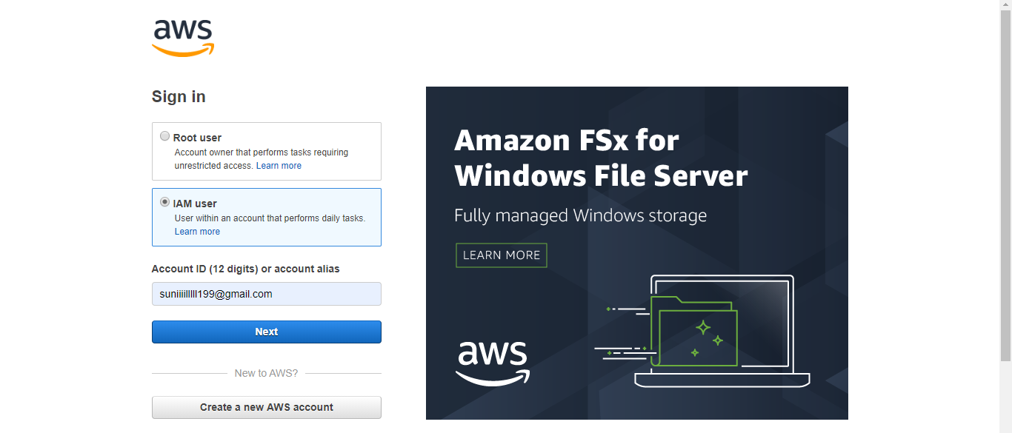

Entered the Password

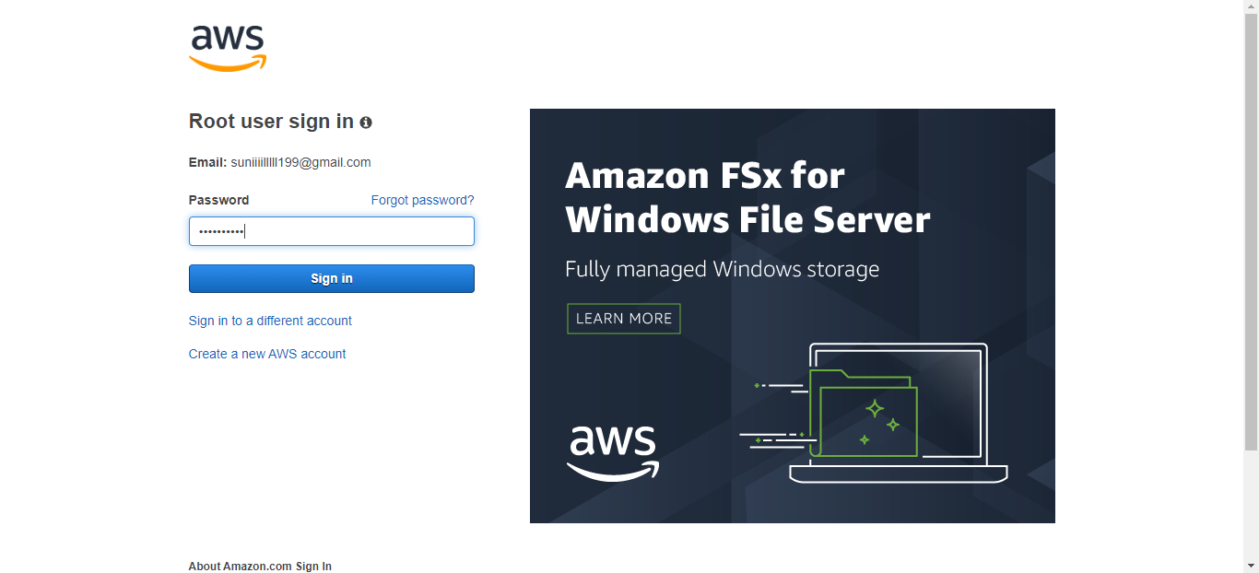

EC2 Dashboard

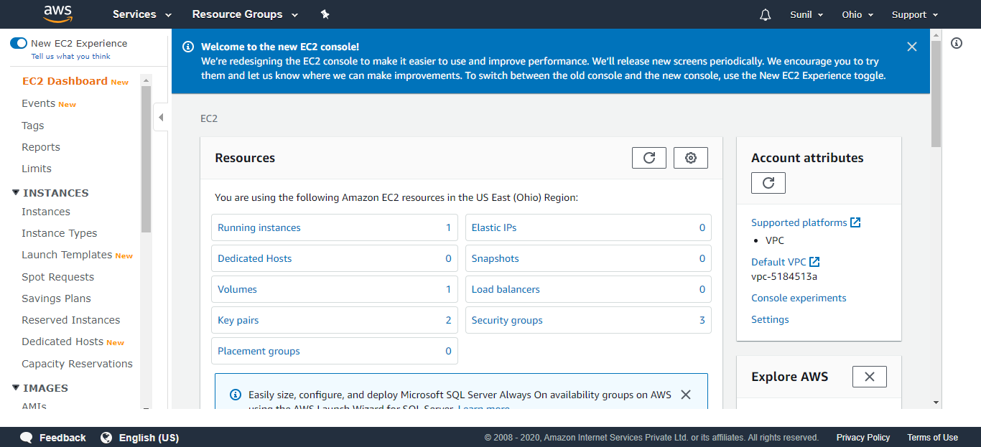

S3 Dashboard

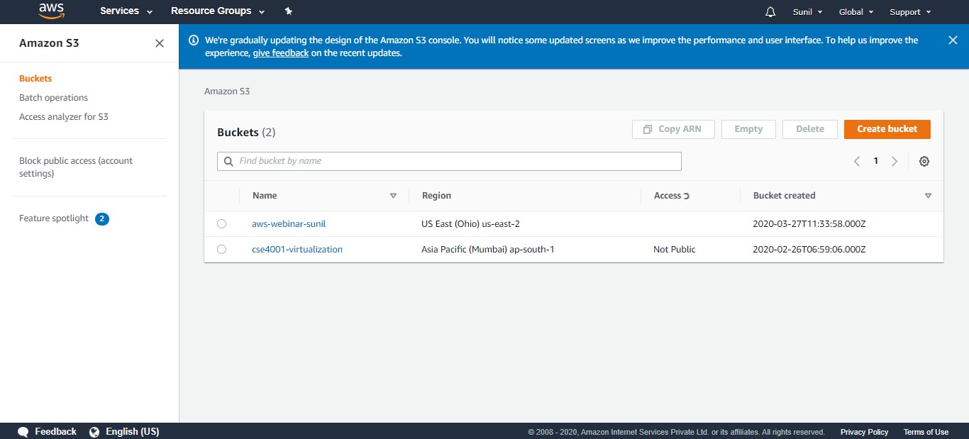

Rekognition Dashboard:

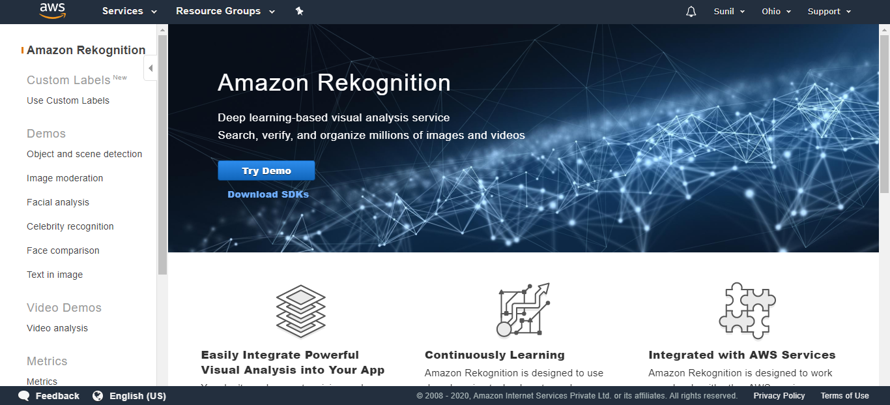

Home Page after Login

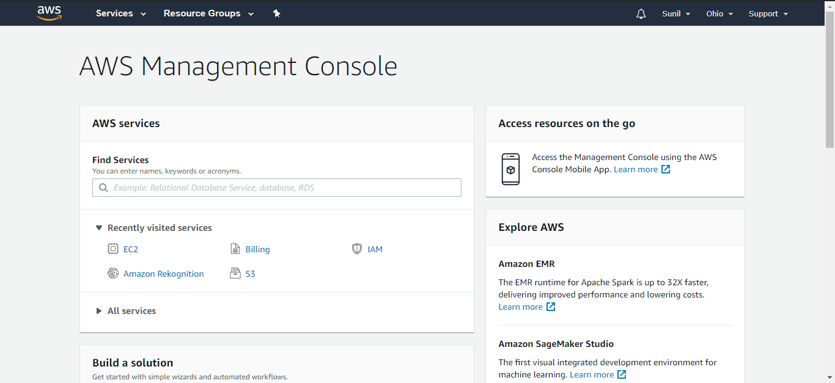

Go to Services and Click on EC2

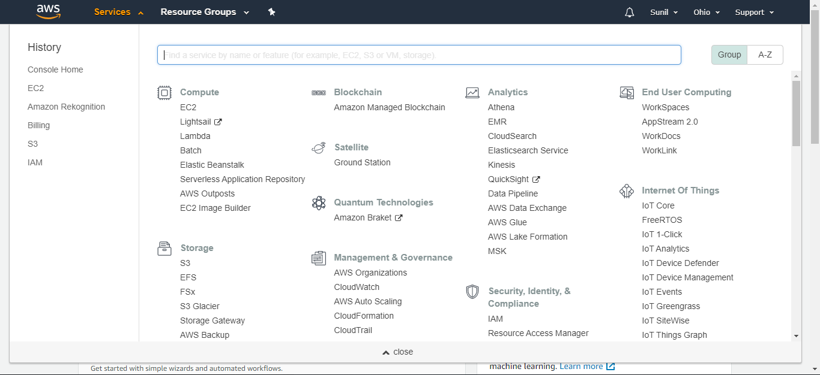

EC2 Dashboard

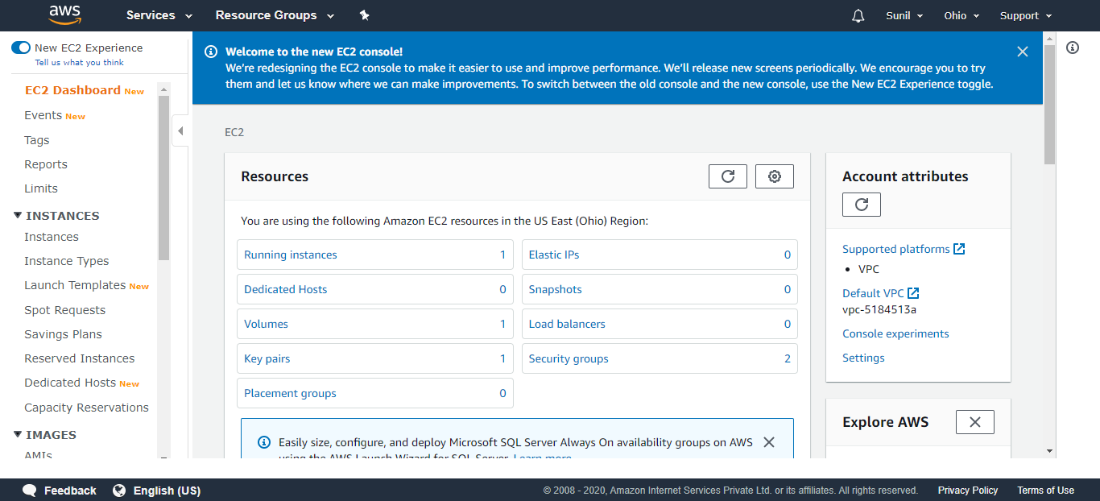

Scroll Down and Click on Launch Instance

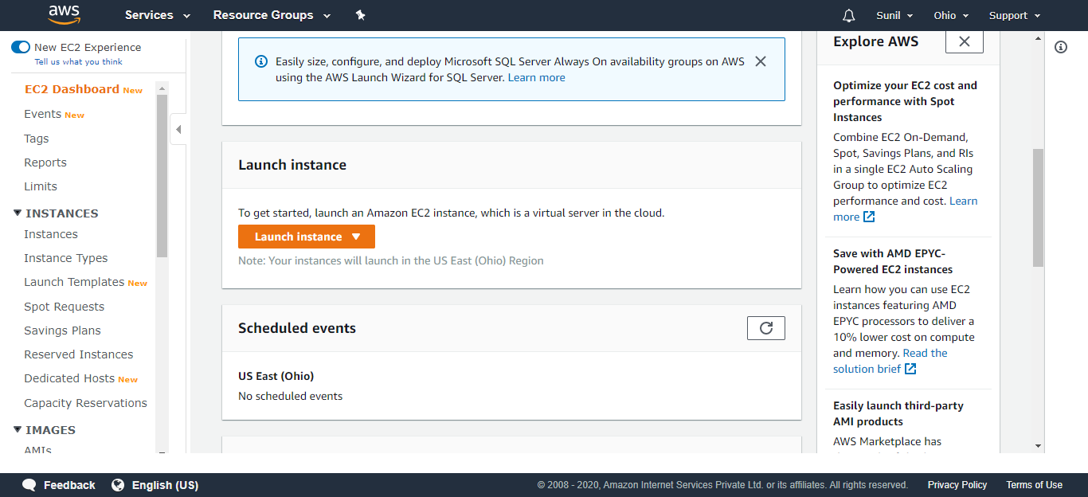

Step 1: Choose an Amazon Machine Image (AMI)

Select Amazon Linux 2 AMI (HVM) which is under Free tier eligible

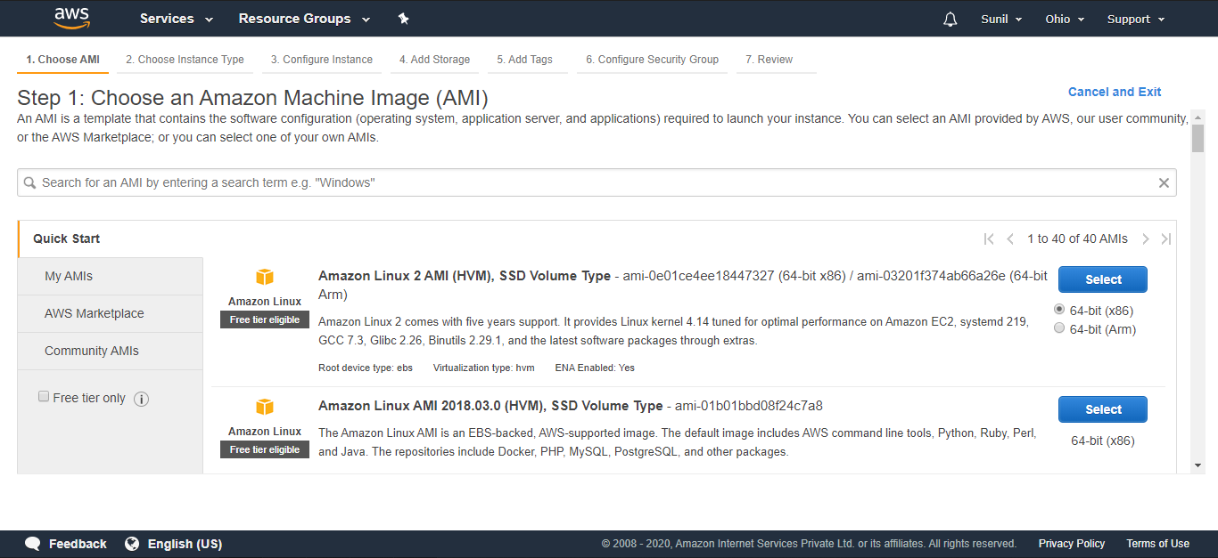

Step 2: Choose an Instance Type

Select Type 12 micro which is under Free tier eligible

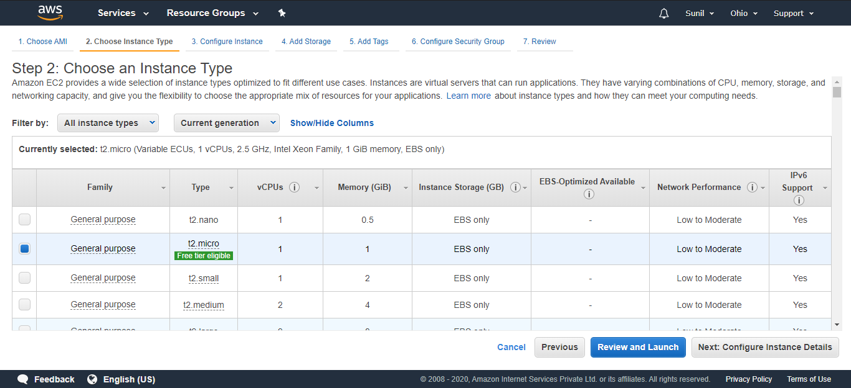

Step 3: Configure Instance Details

Press Next: Add Storage

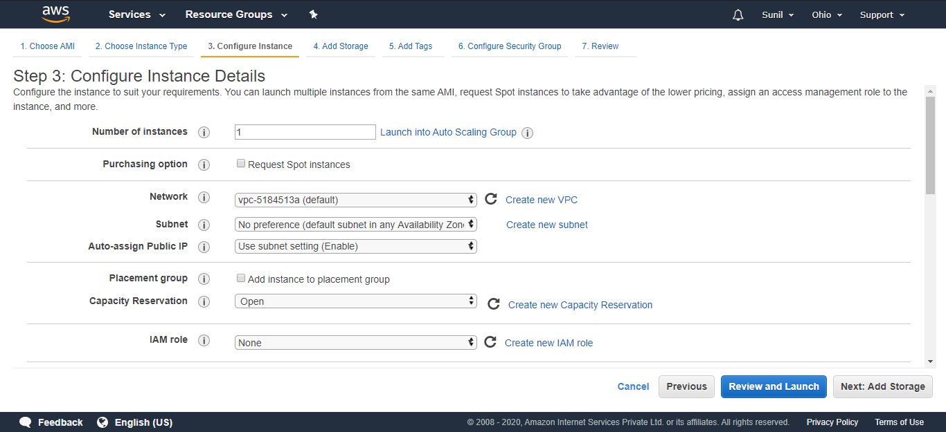

Step 4: Add Storage

Leave everything default and Click on Next: Add Tags

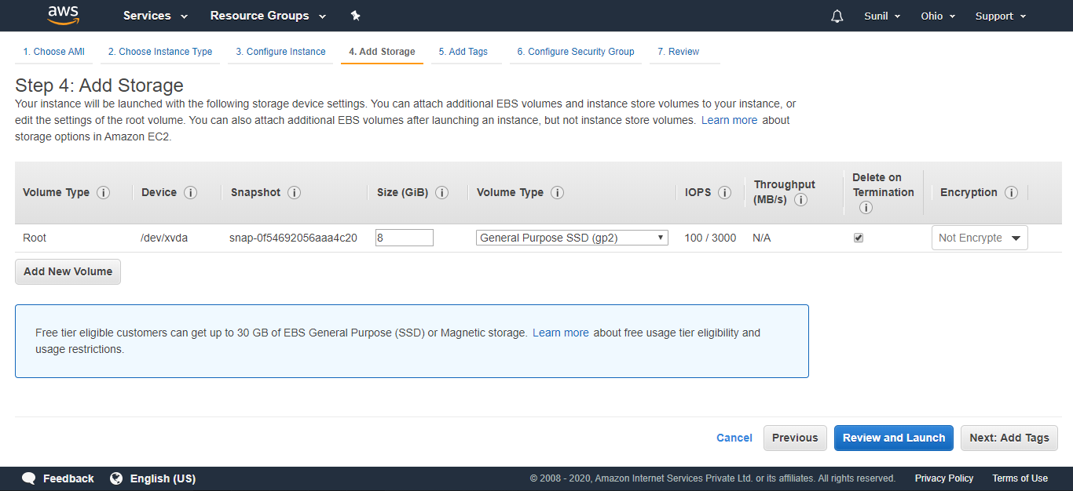

Step 5: Add Tags

Press Next: Configure Security Group

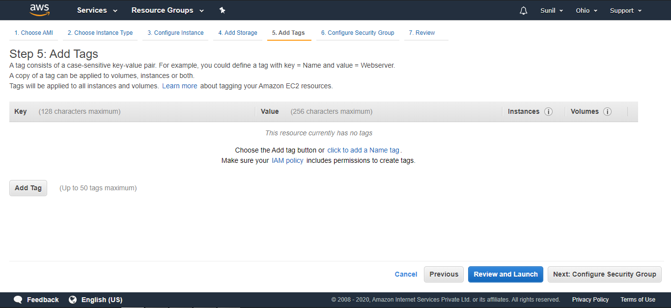

Step 6: Configure Security Group

Leave everything default and Click on Review and Launch

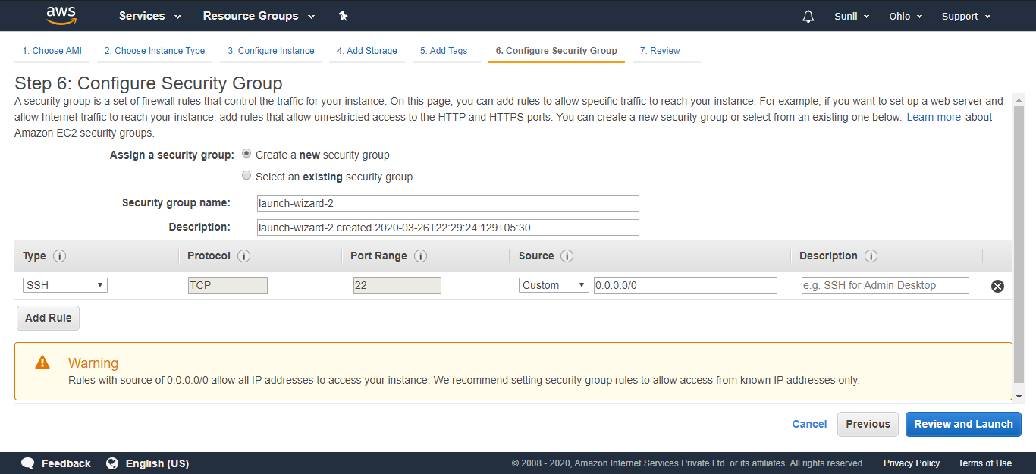

Step 7: Review Instance Launch

Scroll Down to Review

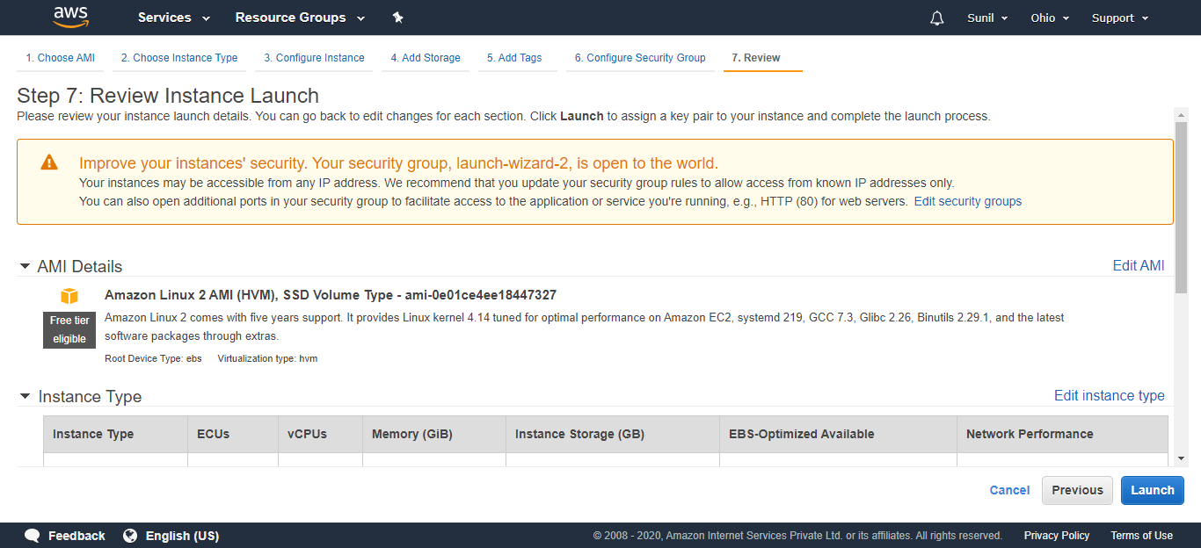

Click on Launch

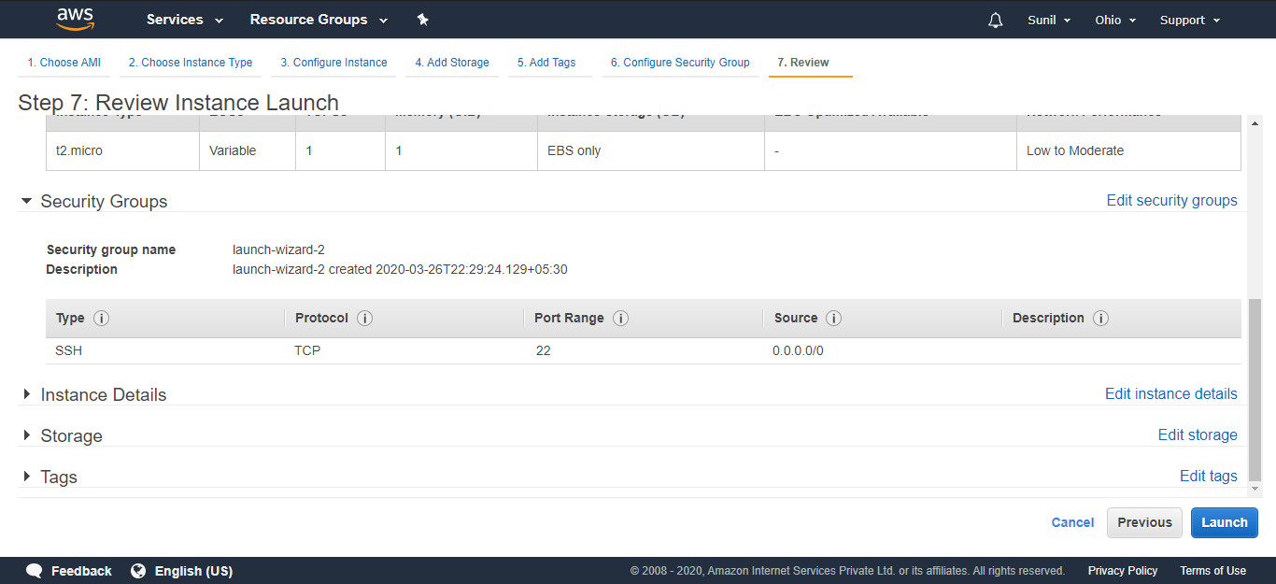

Create a New Key Pair

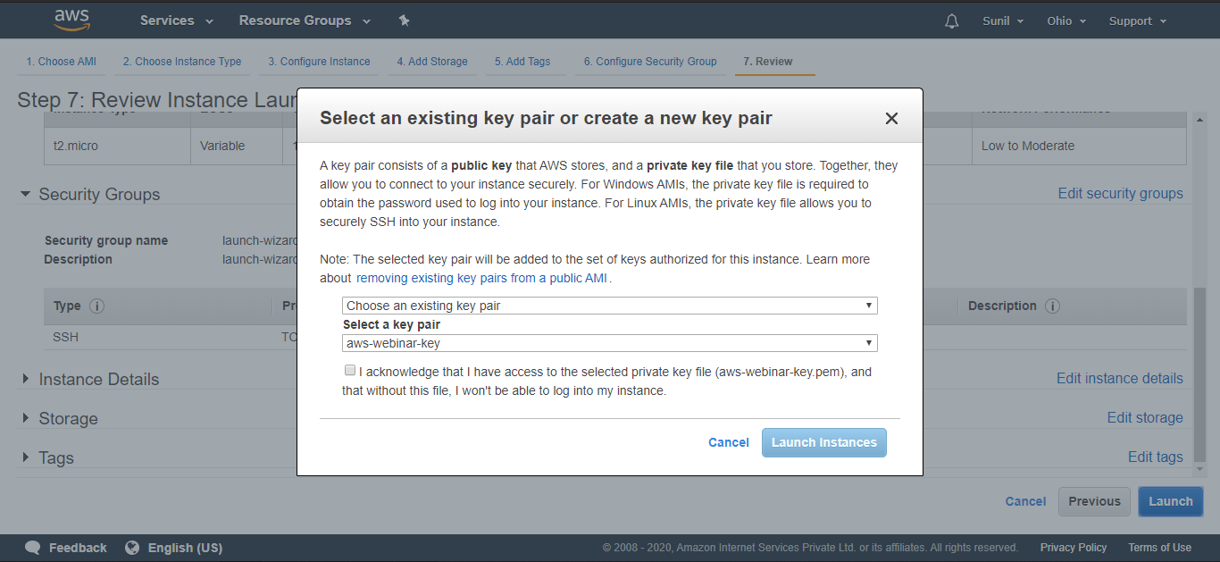

Give a Name to Key pair and Download the Key pair with extension .pem

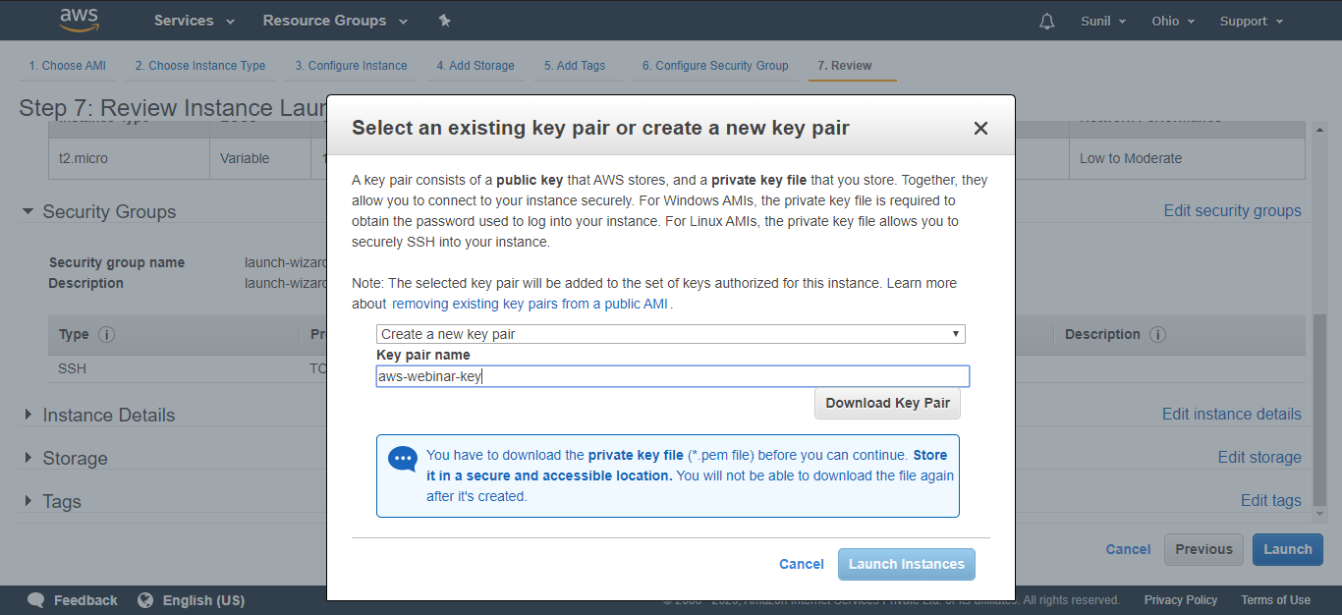

Launch Instance

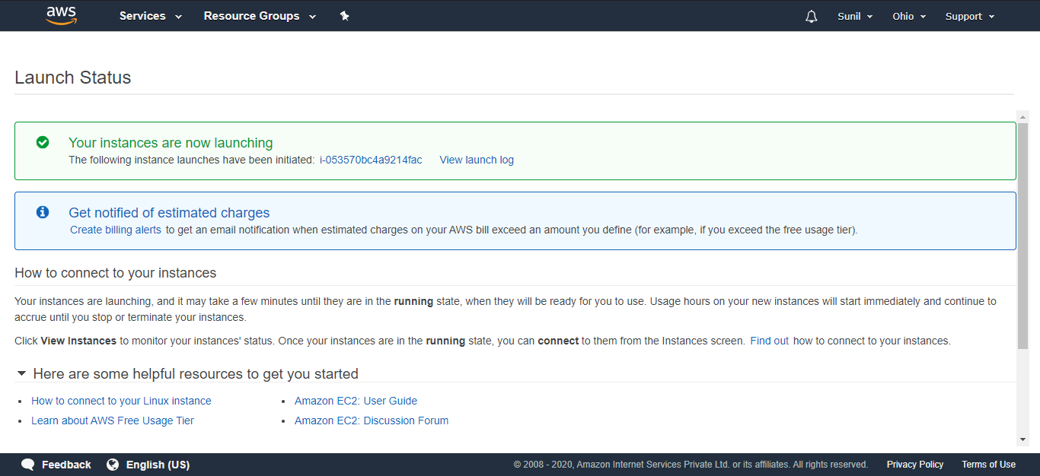

Check for running Instance and copy the IP address of Instance

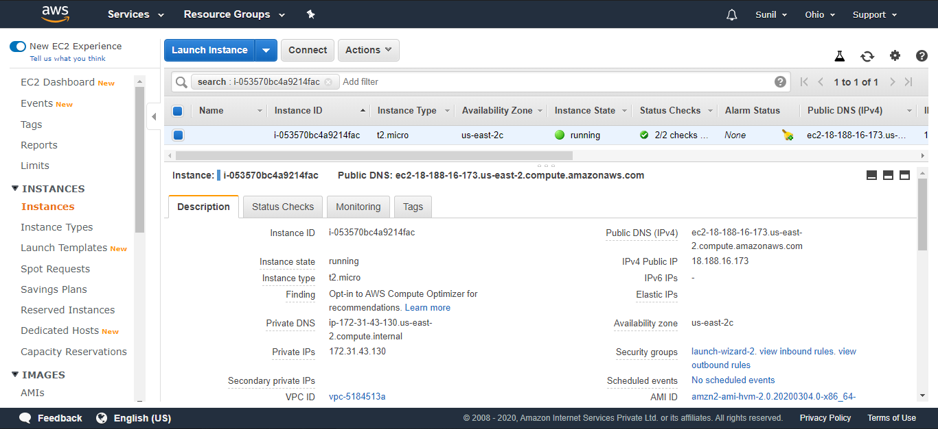

Paste the IP address on web Browser

The site can’t be reached

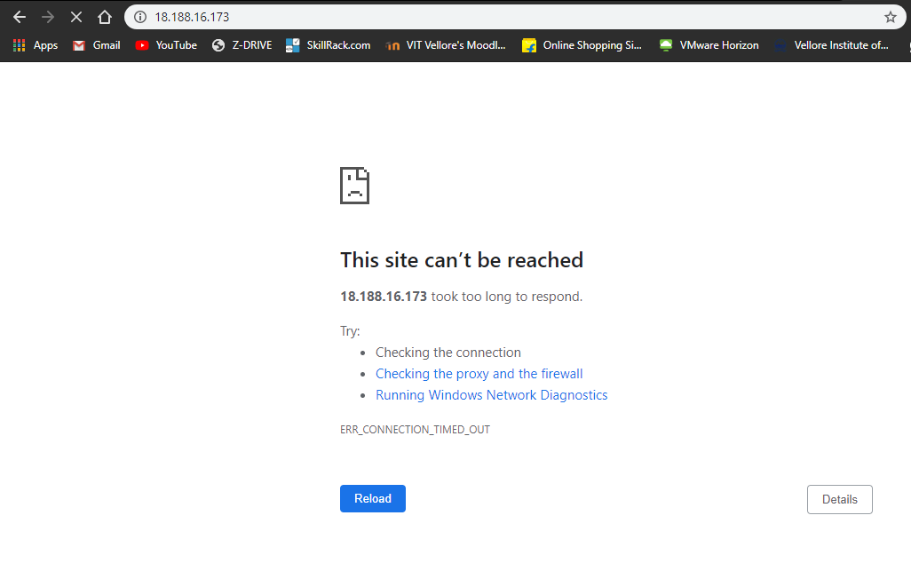

Download and Install PuTTY

Procedure to convert extension of Key pair from .pem to .ppk

Open PuTTY Key Generator and Click on Load

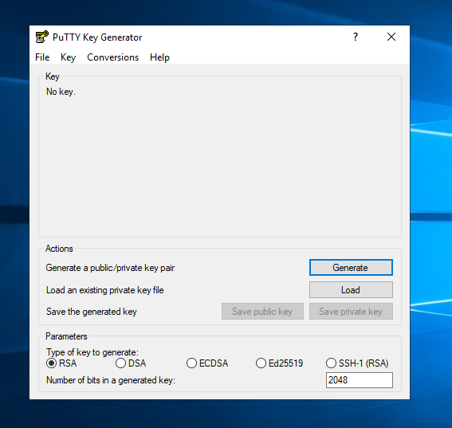

Choose the Key pair with .pem extension

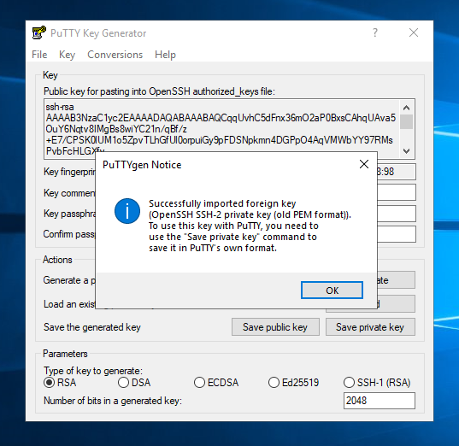

Click on Save private key

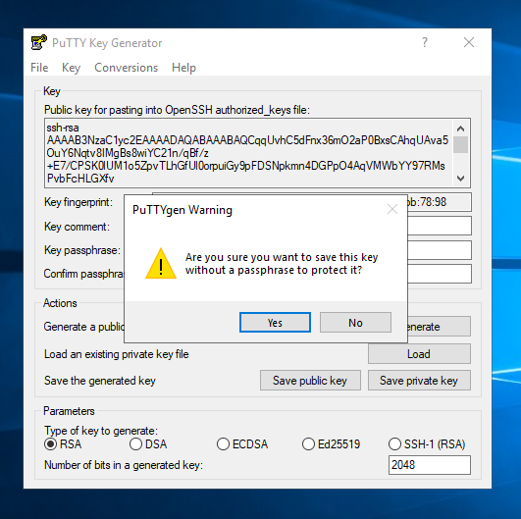

The Key pair with extension .ppk is generated

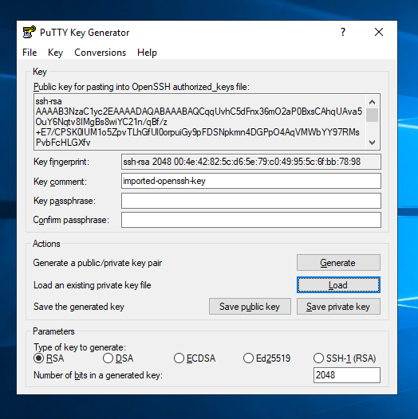

Open PuTTY Configuration and Enter the IP address of running Instance

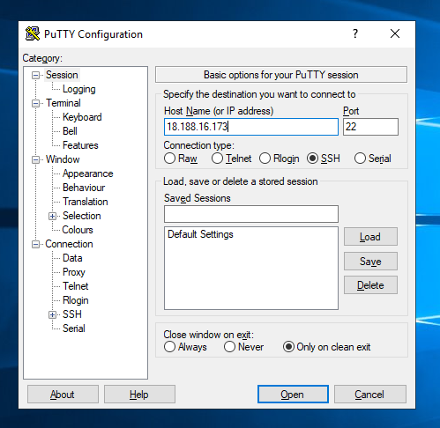

Click on SSH and the on Auth and browse the Key pair with .ppk extension

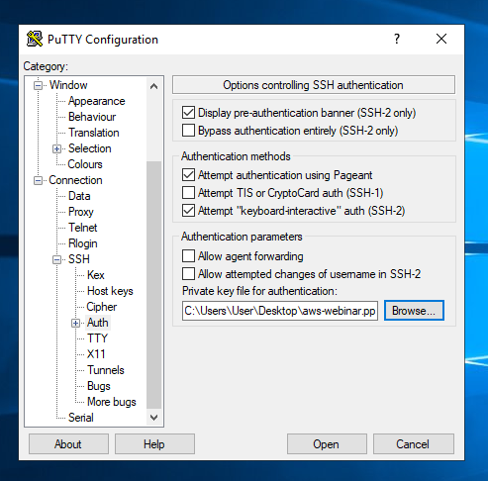

You will be Directed to EC2 with Black Screen

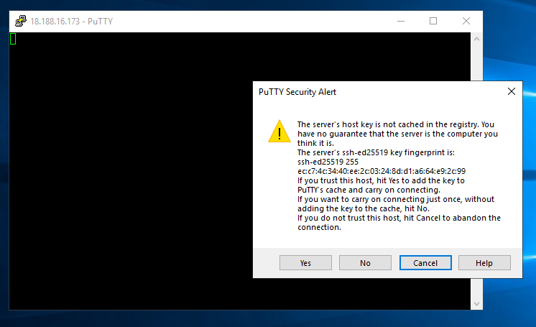

Login as: ec2-user

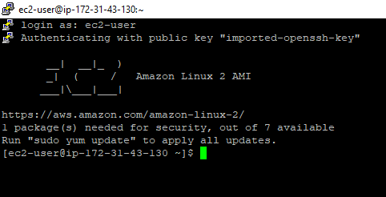

Install Apache with the following command

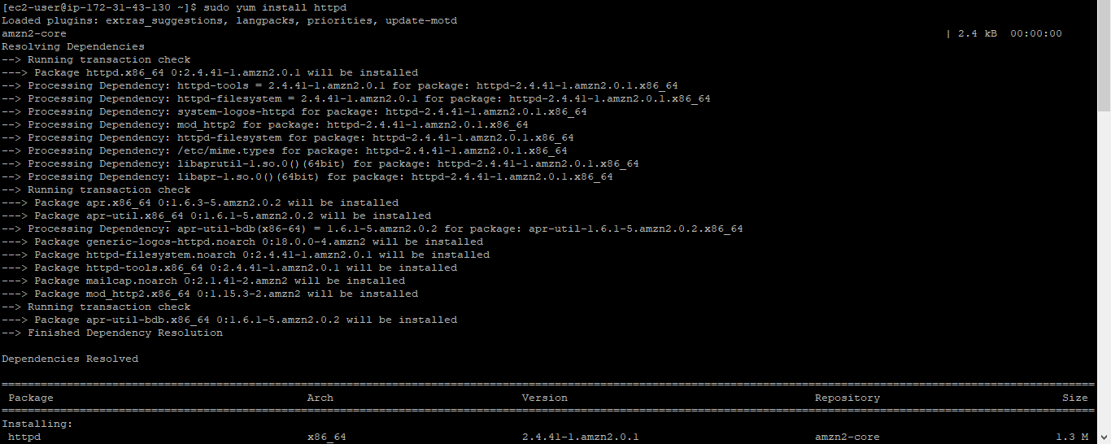

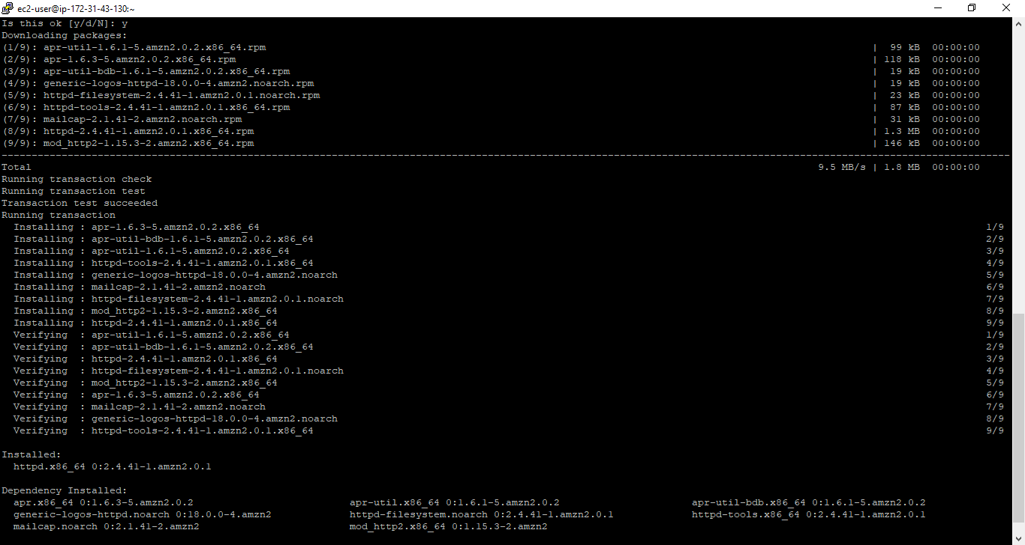

Start the service using following command

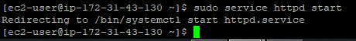

Check the status with the following command

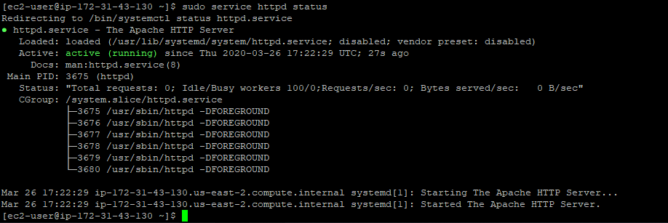

Change the Directory and Create index.html file



Press ‘i’

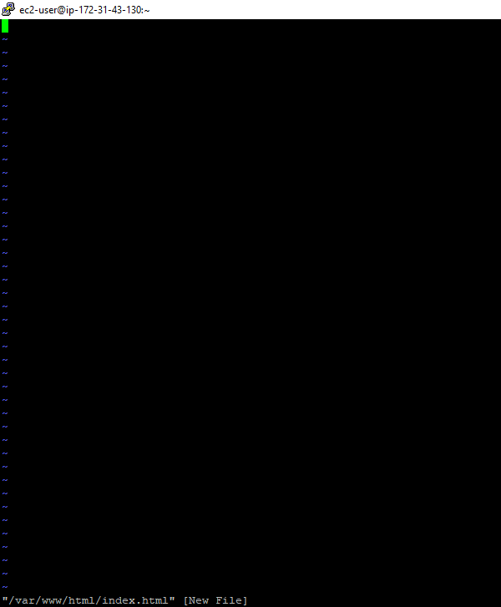

Enter Anything

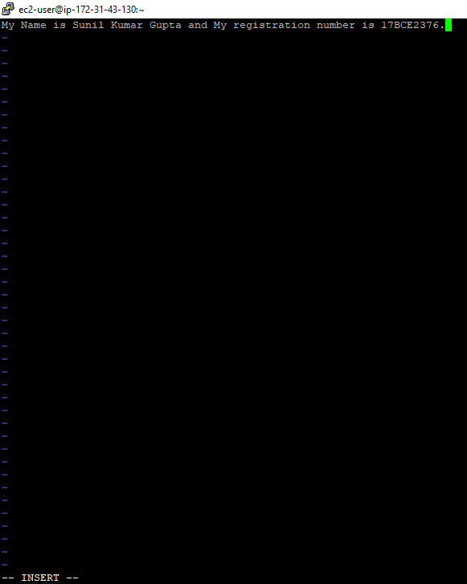

Press Esc followed by :wq and Press Enter

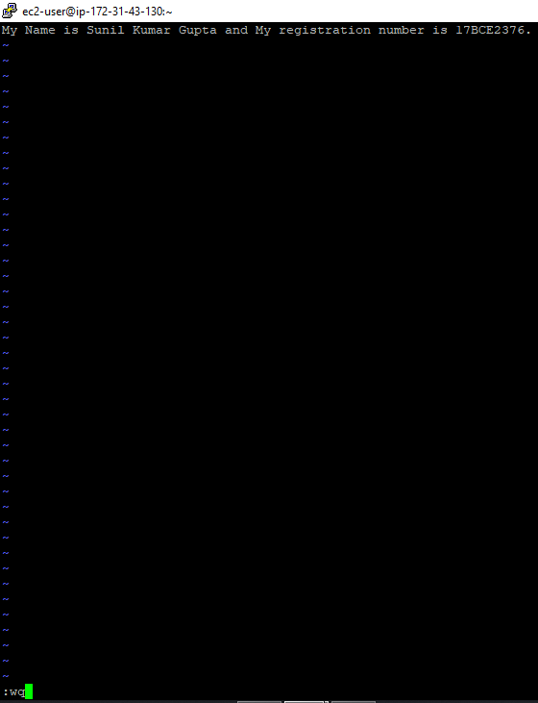

Select the running Instance and Check the Security Groups

Click on Security Groups

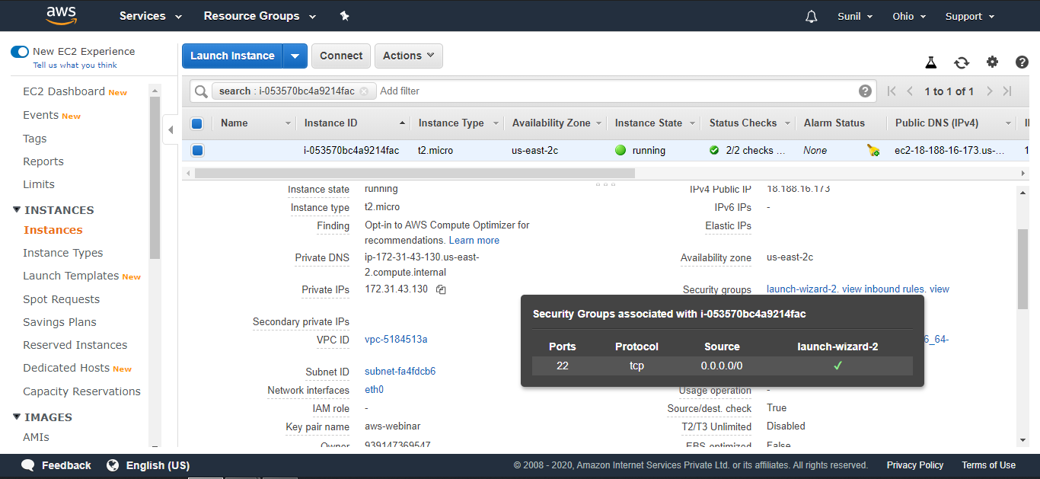

Click on available Security group

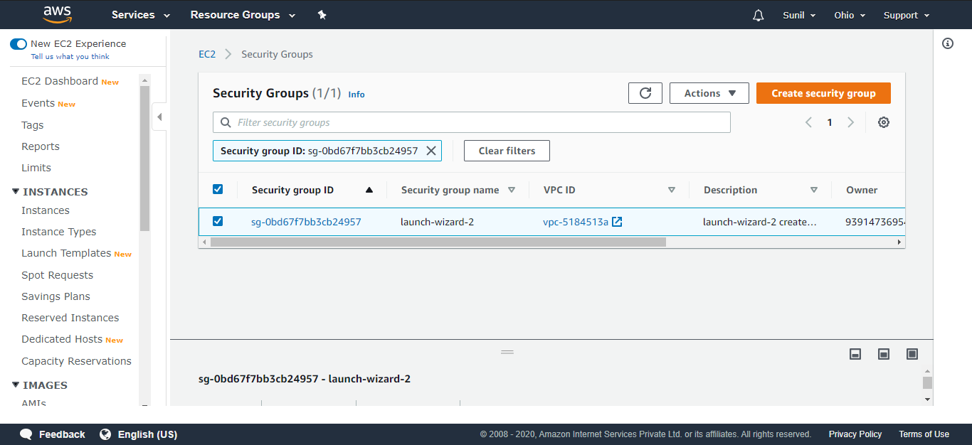

Click on Edit Inbound rules

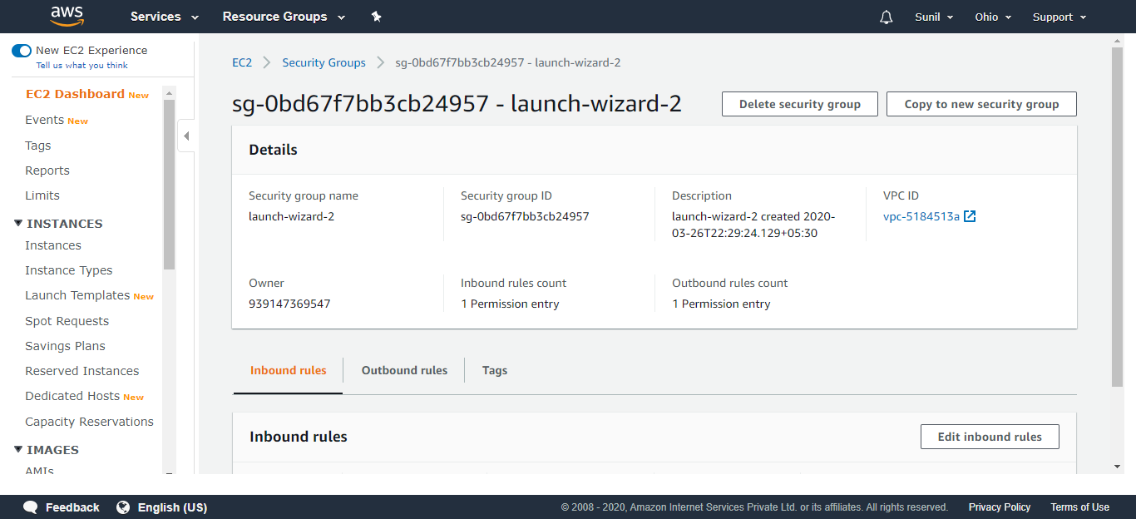

Click on Add rule

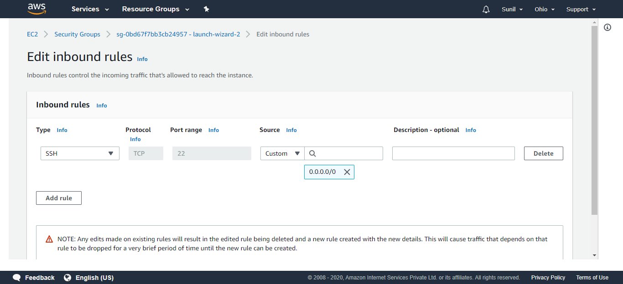

Select Type HTTP and Source Anywhere

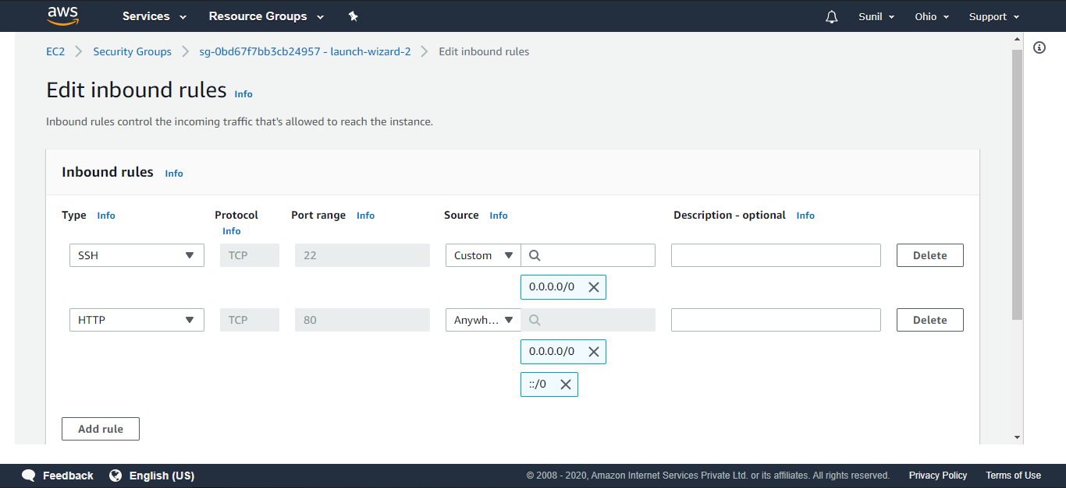

Scroll Down and Save rules

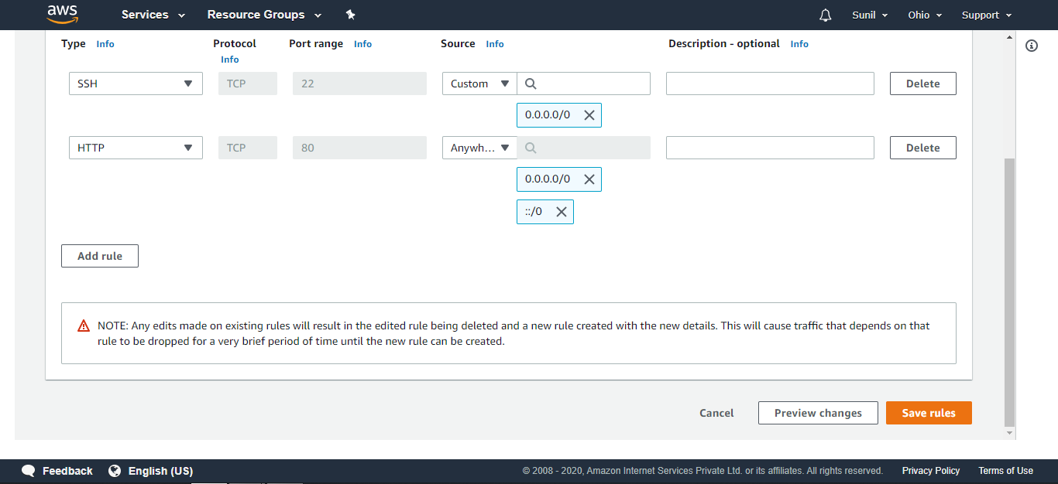

Security group rules successfully modified

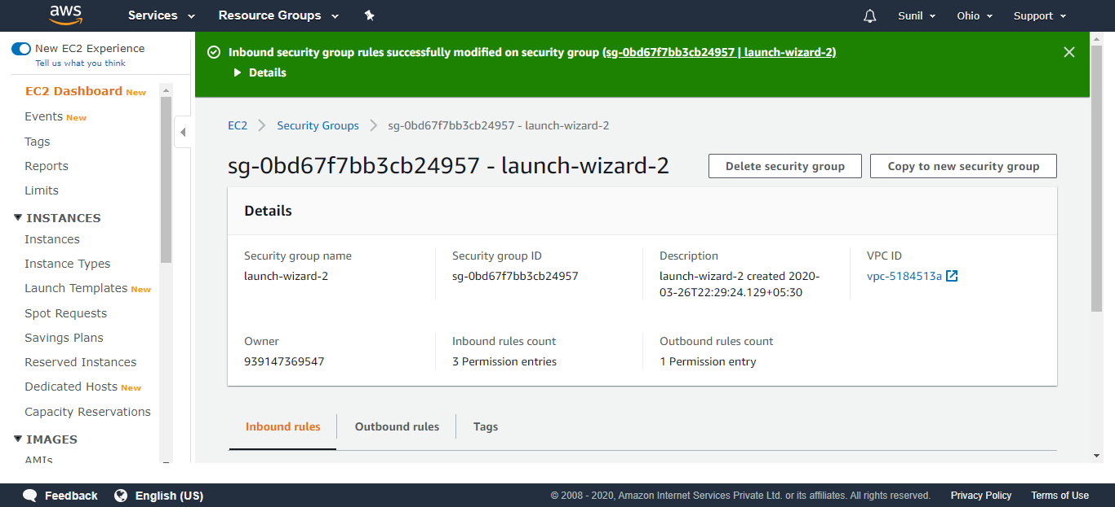

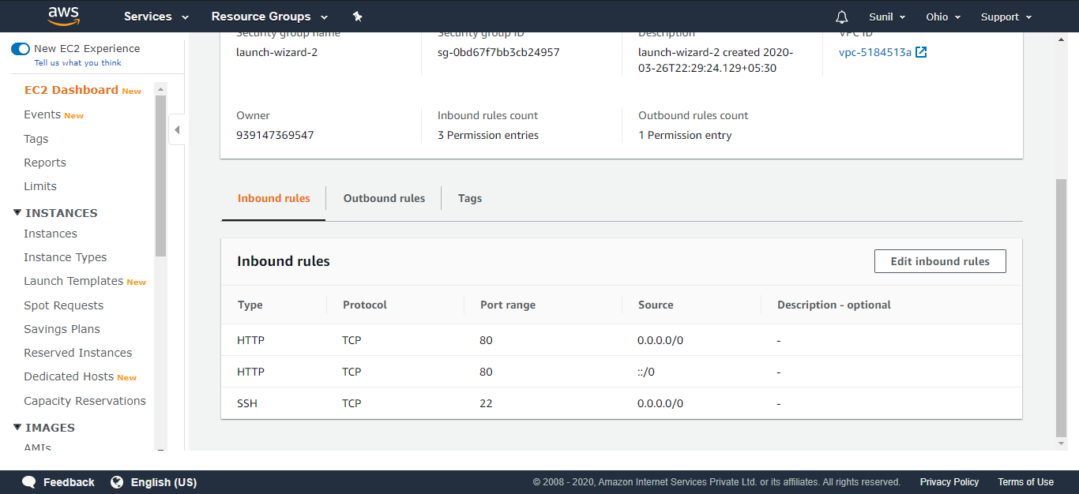

Now Again Enter the IP address of running instance on Browser

You can see the content of index.html

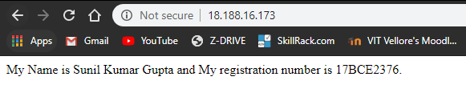

I have created one more Instance to demonstrate how to terminate an instance

Go to EC2 Dashboard and Click on running Instances

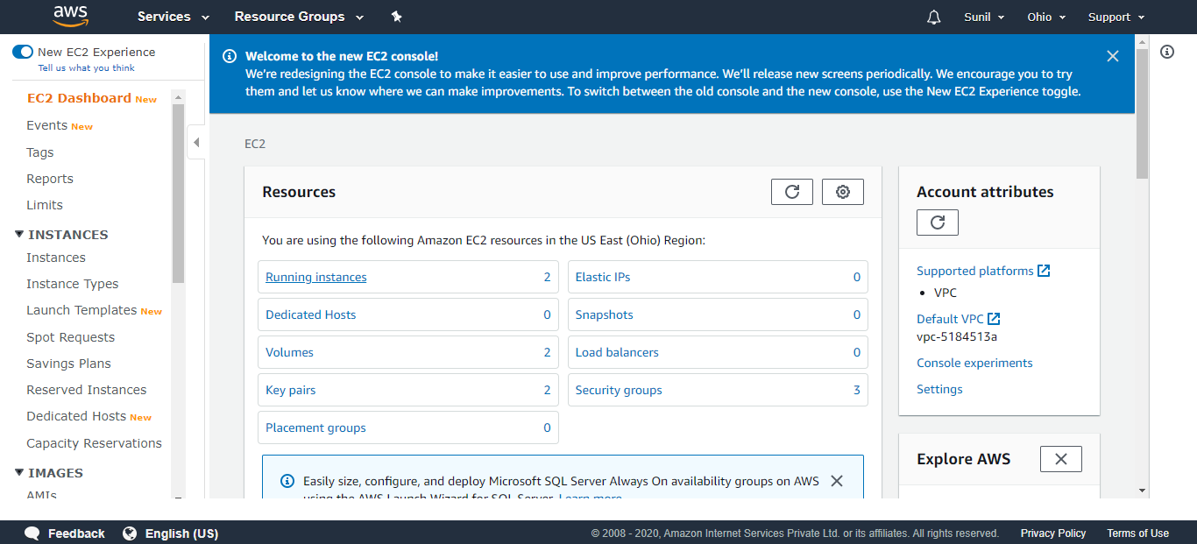

Select the instance which is to be terminated and Click on Action

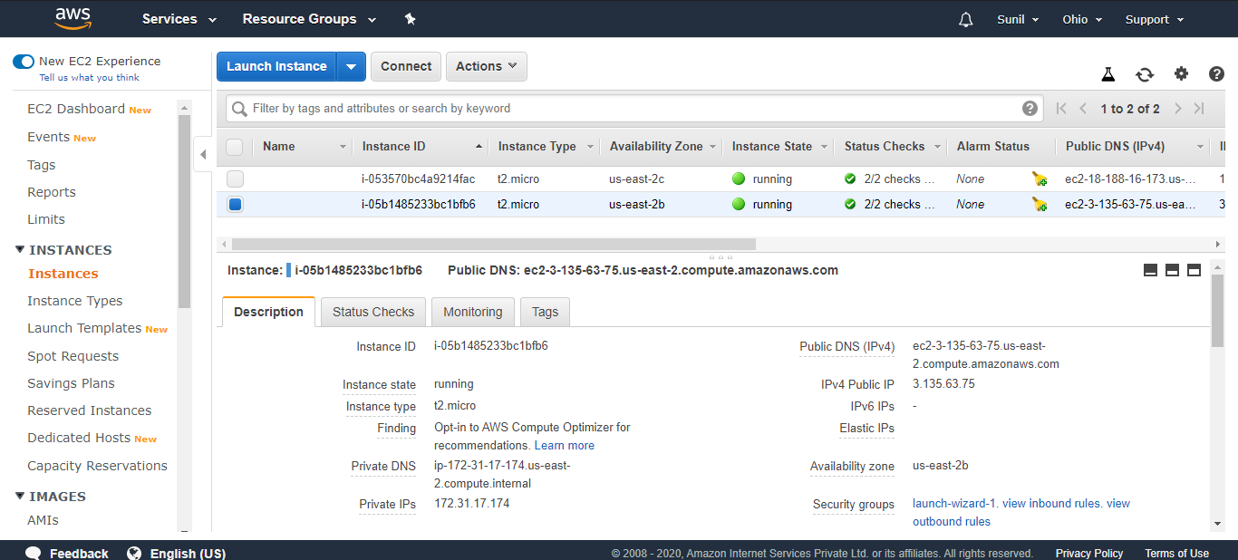

Go to Instance State and Click on Terminate

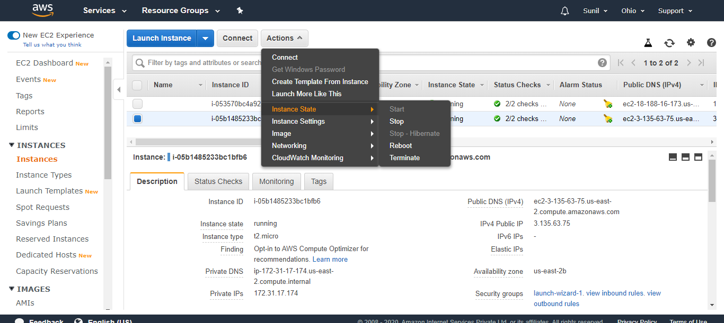

Confirm by Clicking on Yes, Terminate

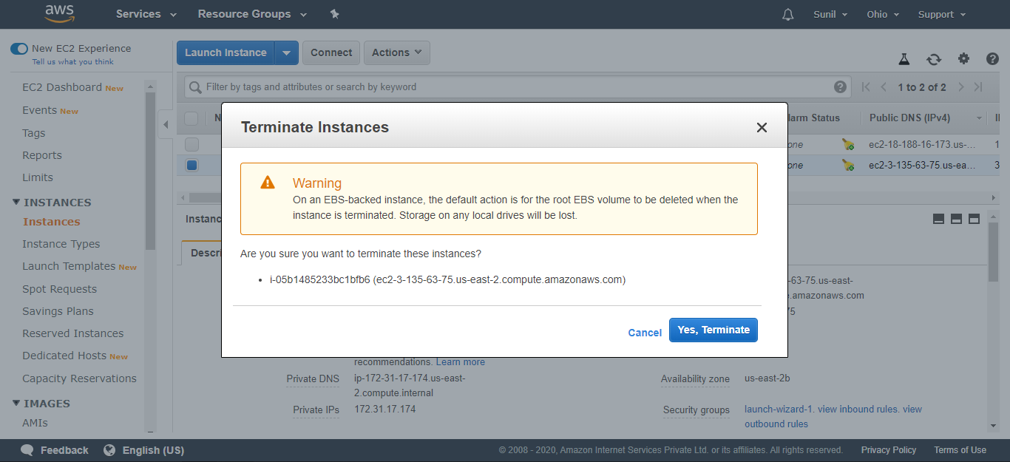

You can see It’s shutting-down

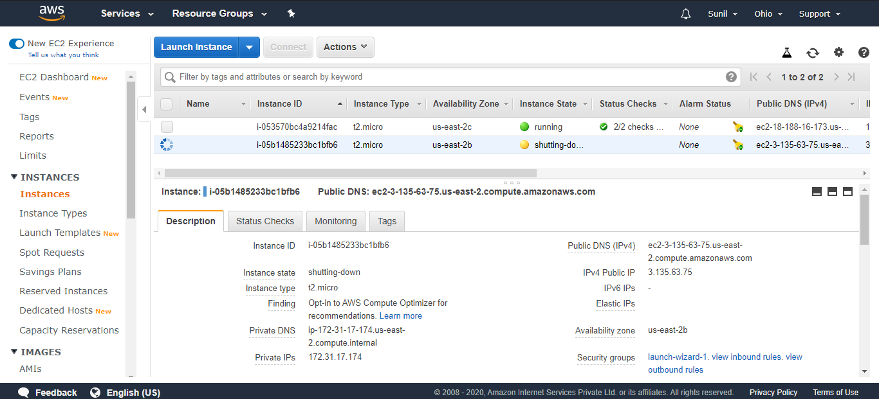

After few seconds, It is terminated

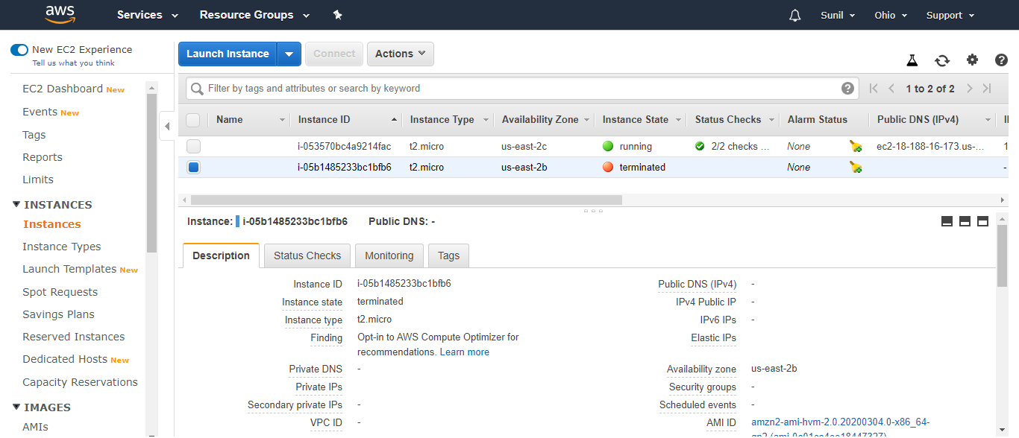

**Creating a Bucket**

Go to Services and Click on S3 under Storage option

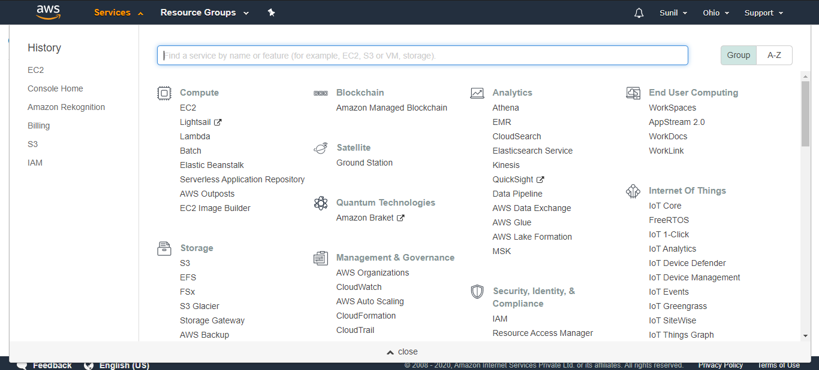

Click on Create bucket

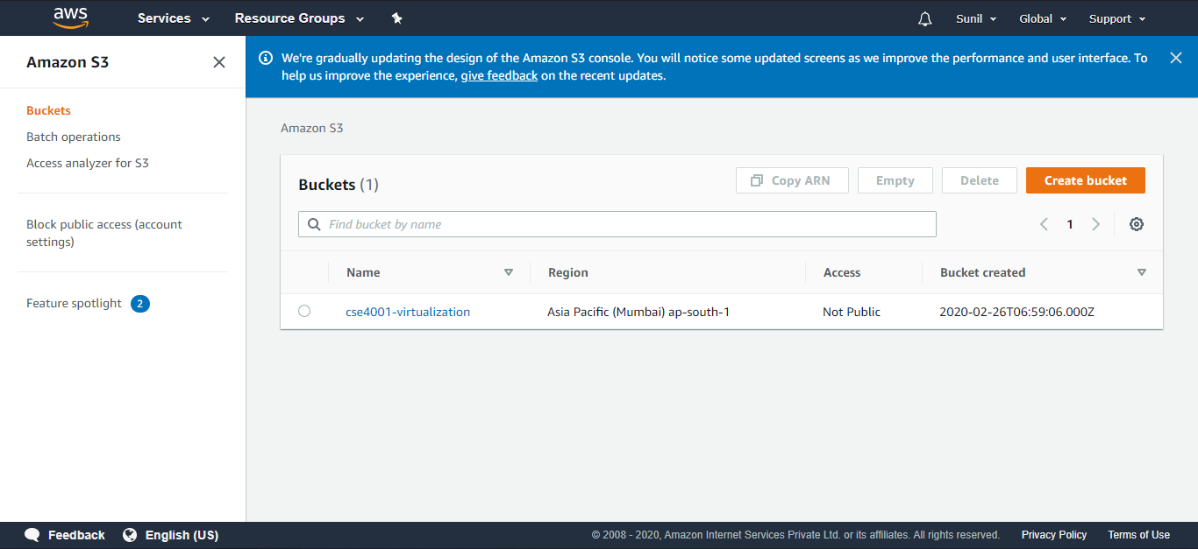

Give an unique bucket name and select the region Ohio

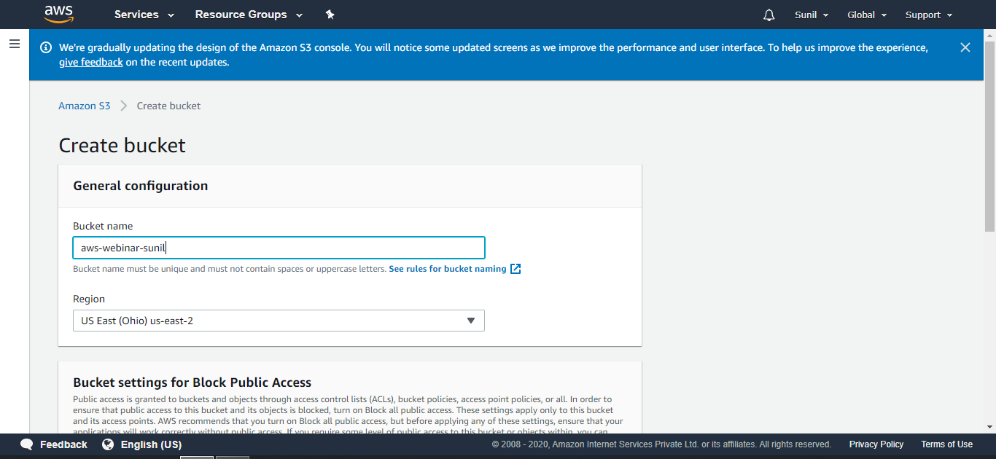

Scroll Down and Click on Create bucket

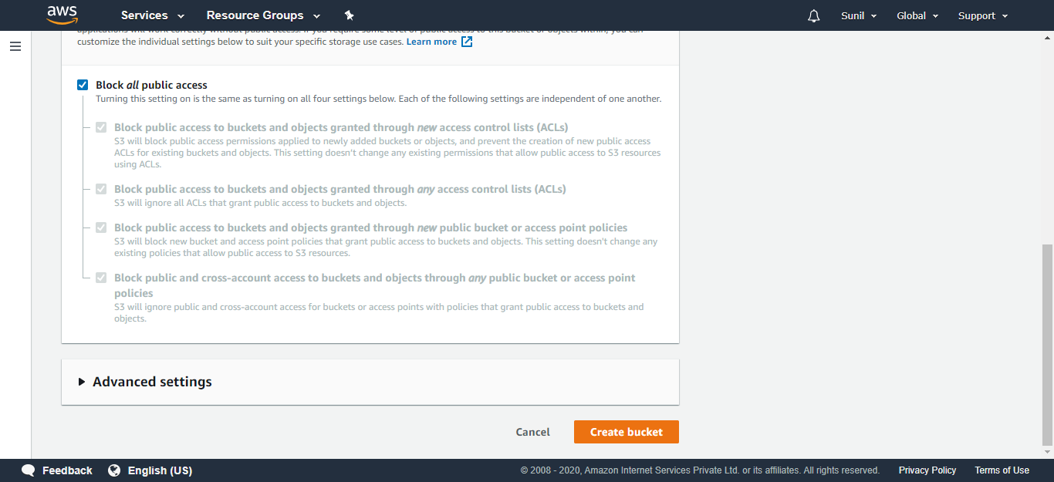

Now, You can see our bucket is created successfully

Click on ‘aws-webinar-sunil’ bucket

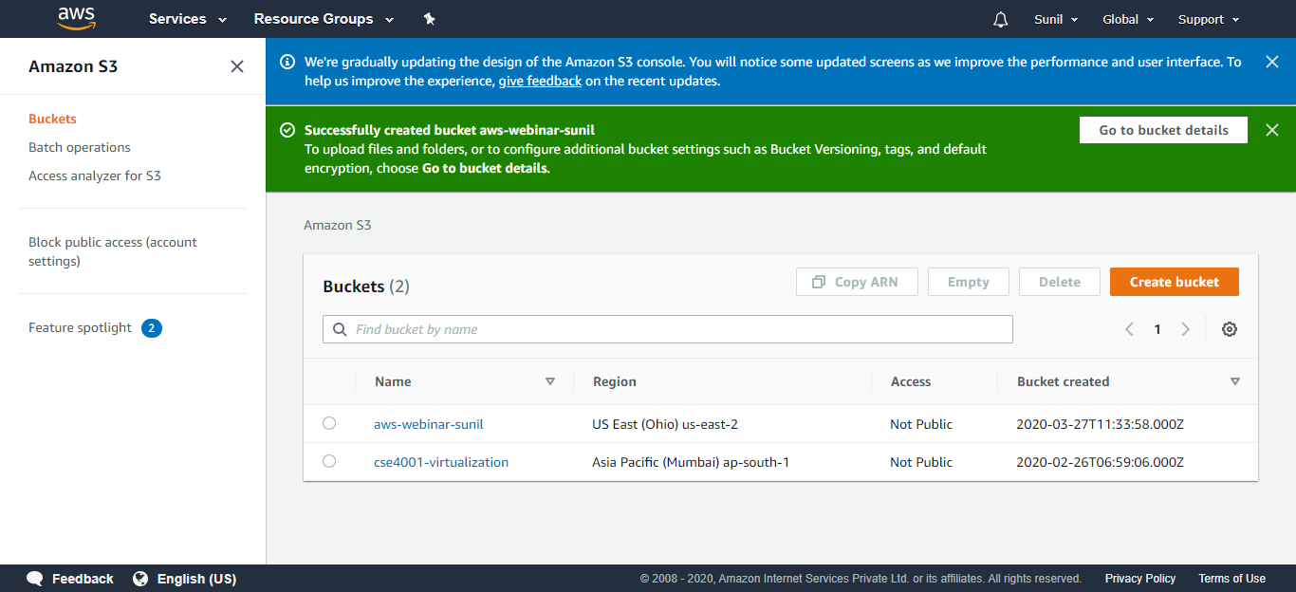

**Uploading an Object**

Click on Add files

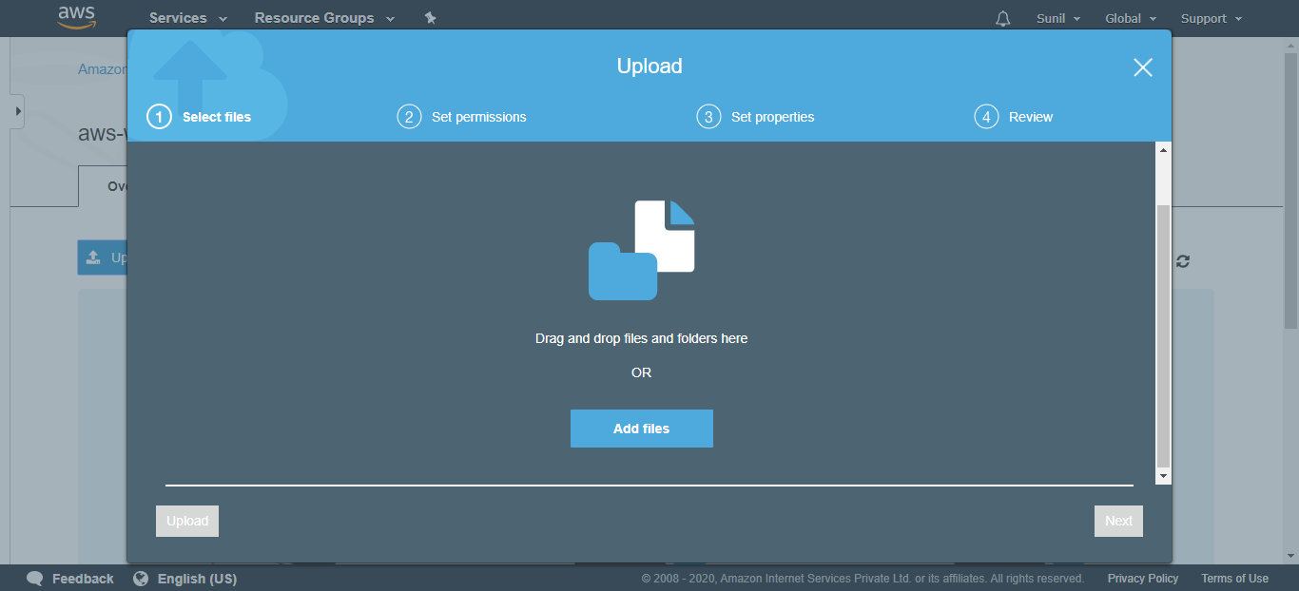

Select any file and Click on Next

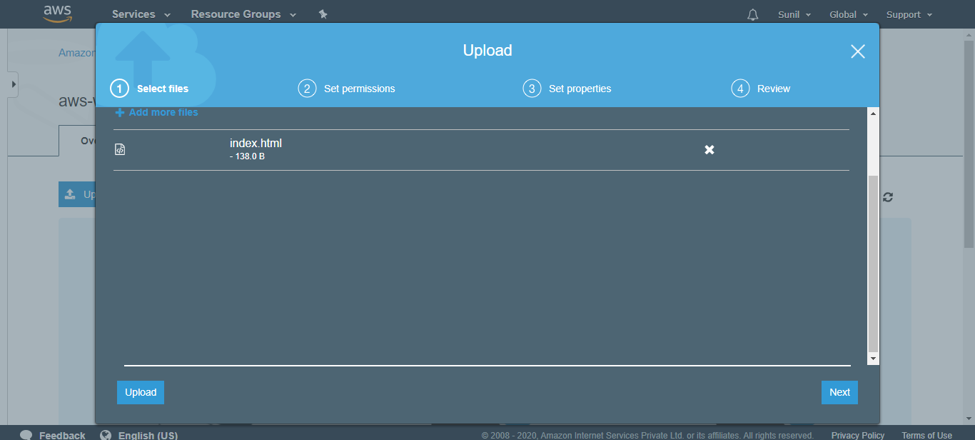

Click Next

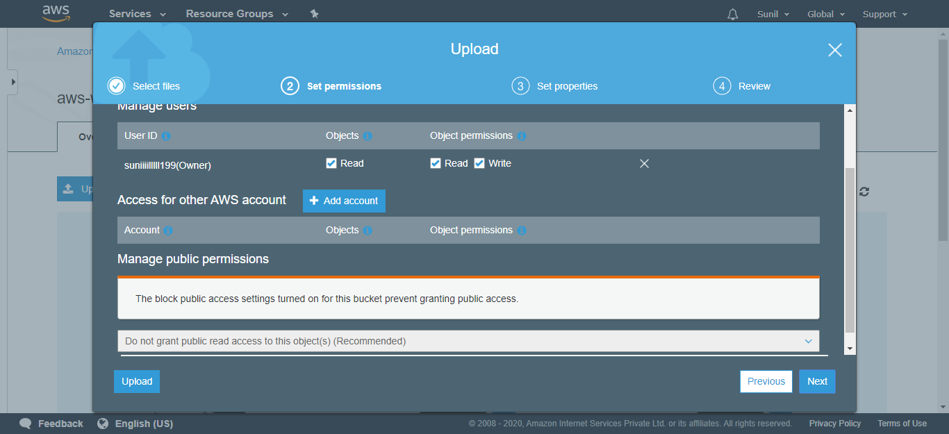

Select Standard and Click Next

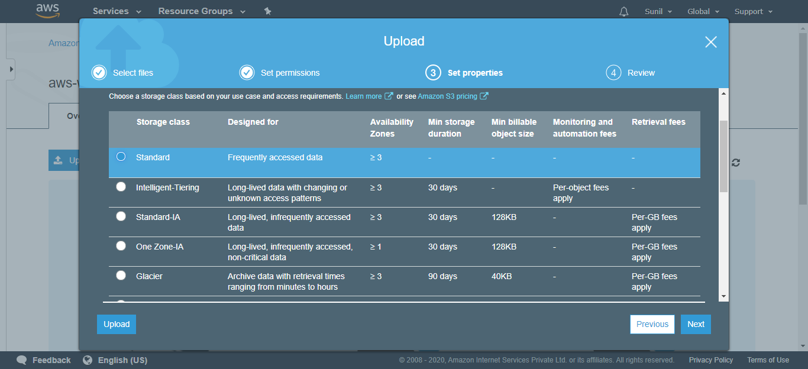

Review and Click on Upload

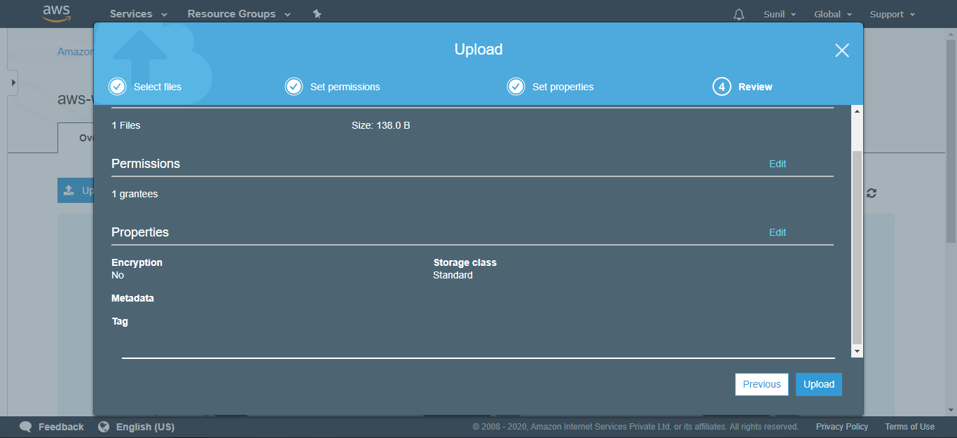

File is Uploaded successfully

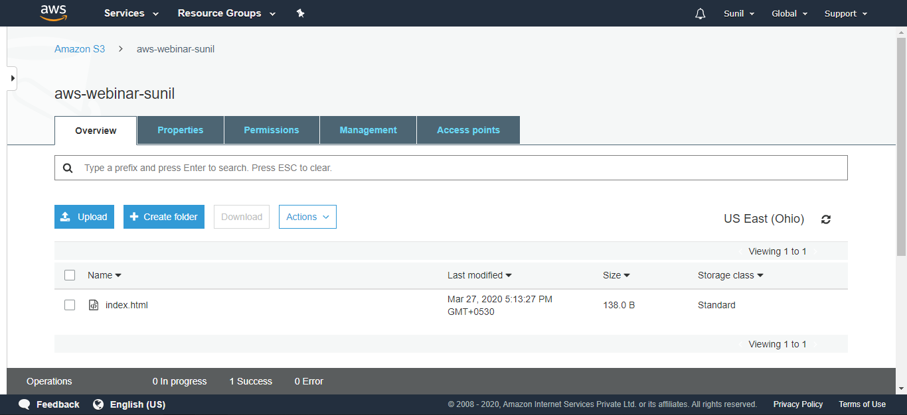

Select the file

And click on overview on Right hand side corner

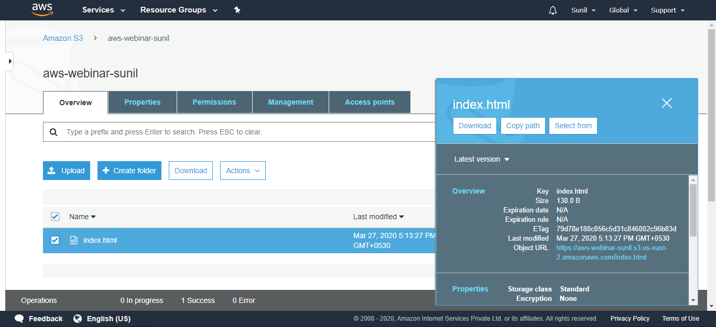

Click on Object URL

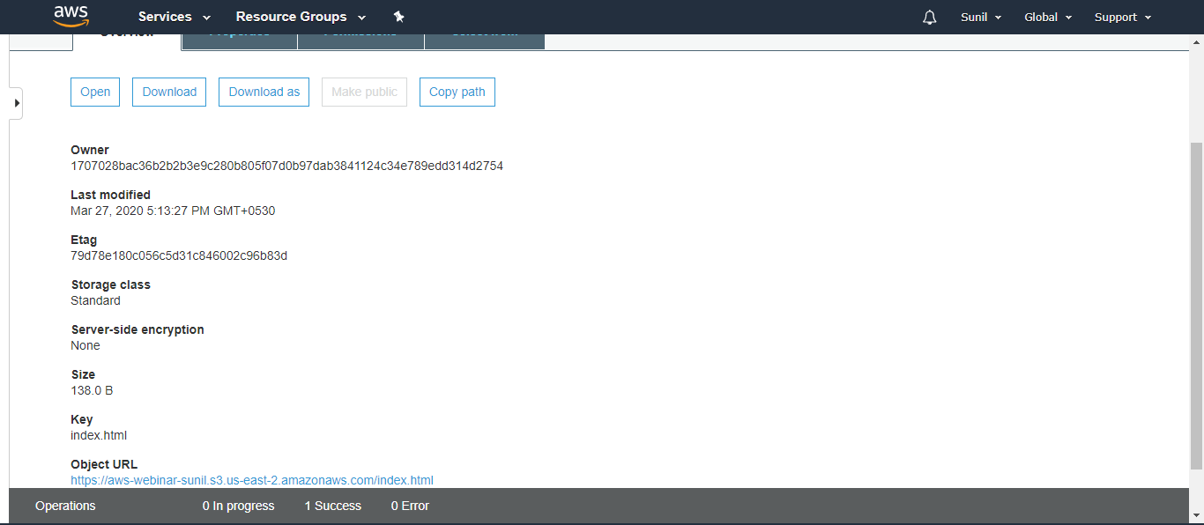

You can see Access is Denied

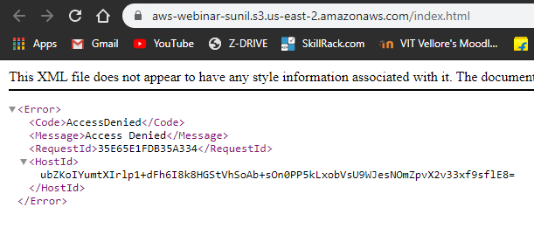

**Enabling Static Website**

Go to S3 bucket and select the ‘aws-webinar-sunil’ Bucket

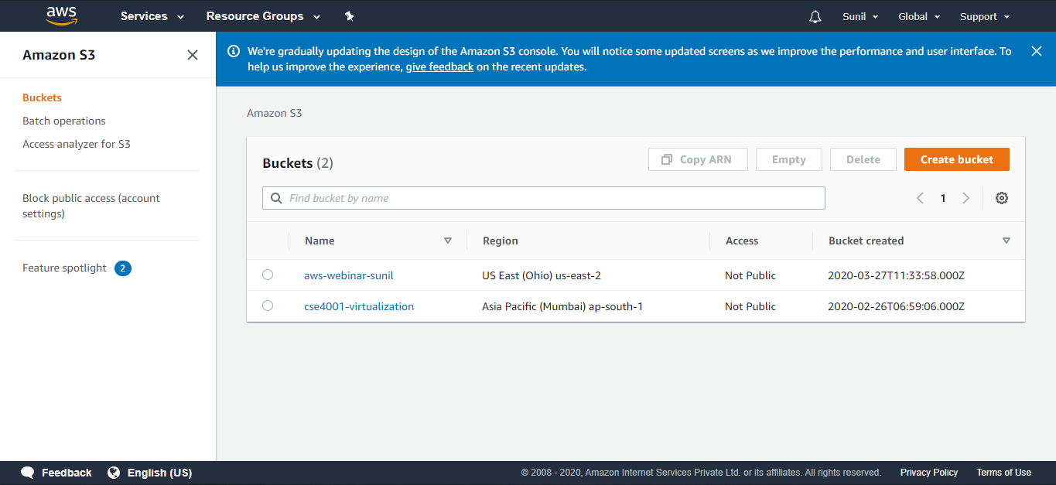

Go to Properties

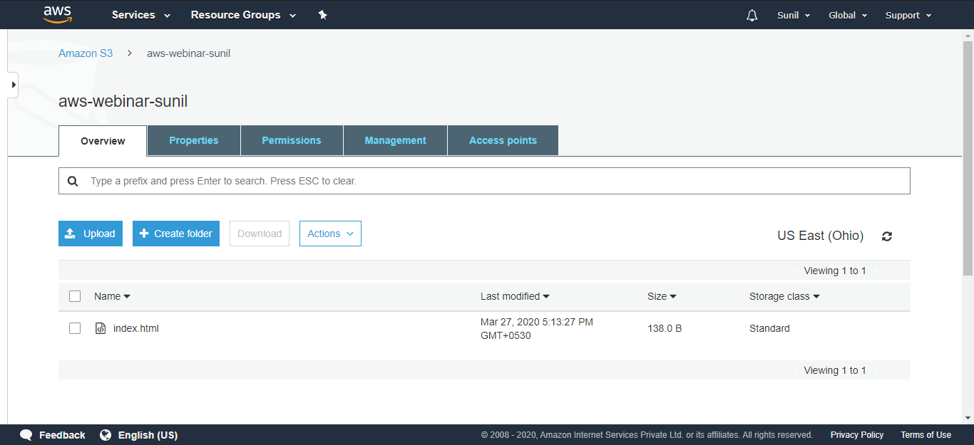

Select Static website hosting

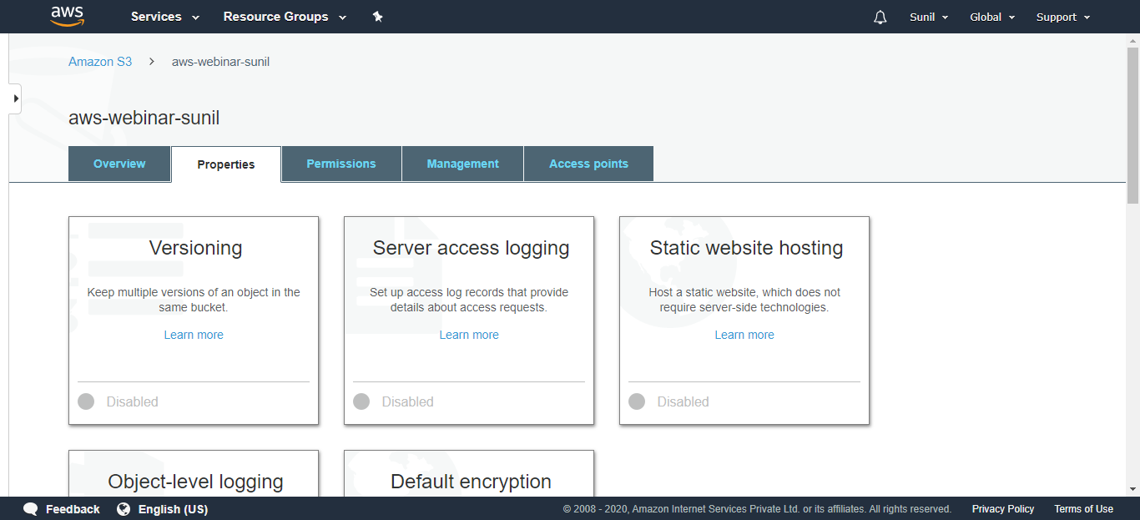

Write the document name (in my case it is index.html) and Click on save (Static Website Enabled)

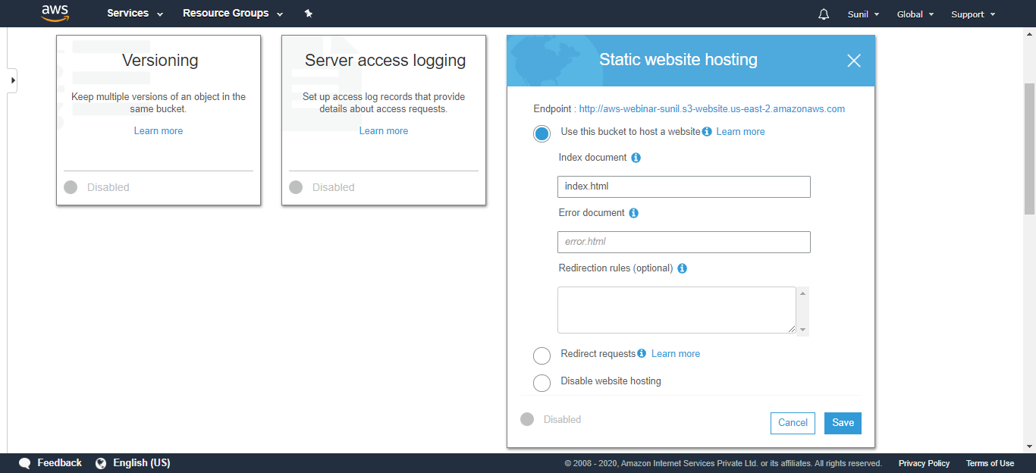

Click on Object URL, Still Access is Denied

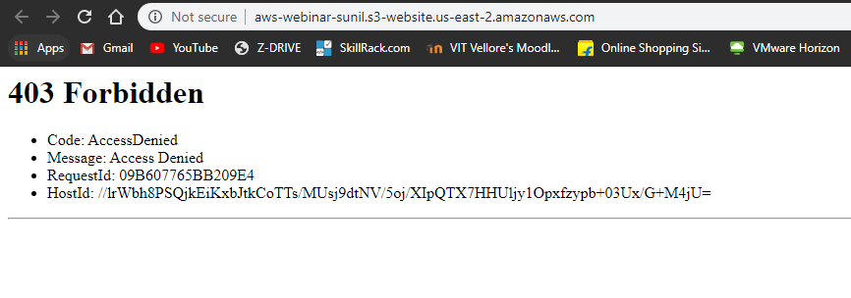

**Making the Object Public**

Go to Permissions and Click on edit on right hand side

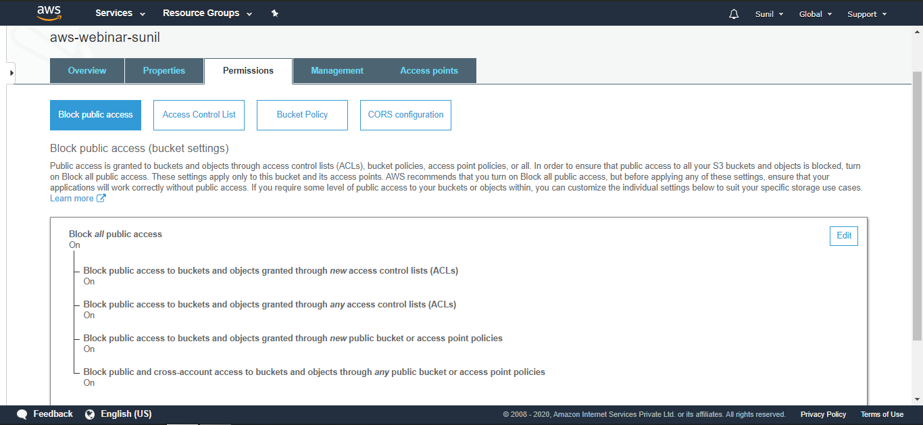

Uncheck Block all public access and confirm as shown below

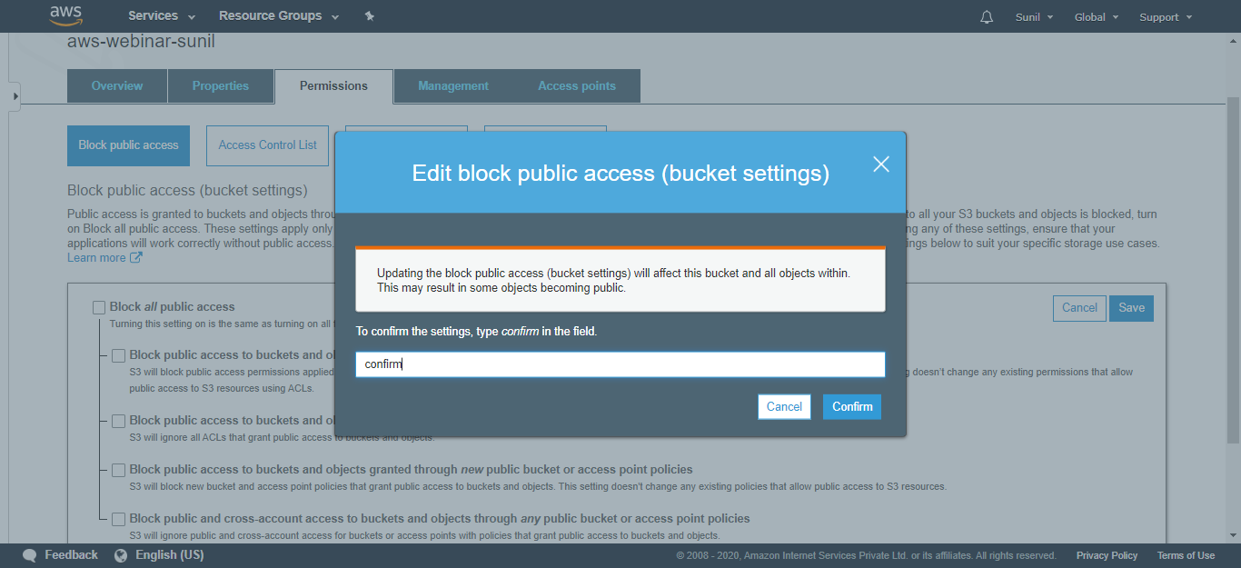

Public access updated successfully

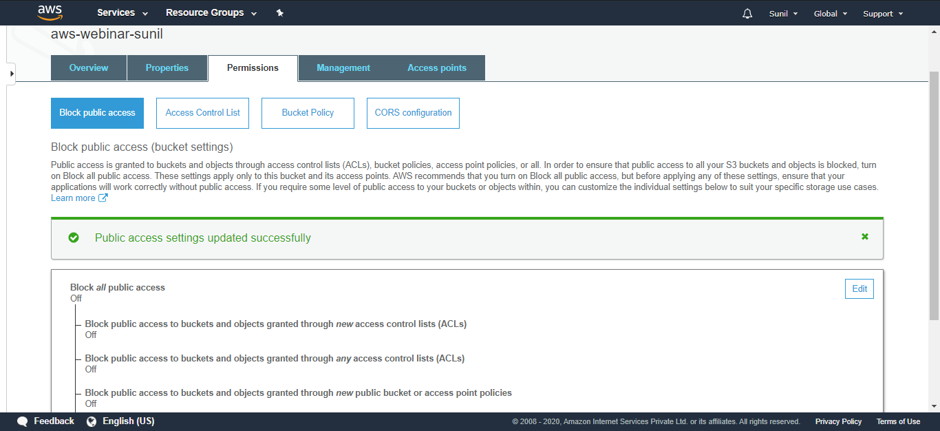

**Check the S3 link on the browser**

Now Click on Object URL, You can see It’s working now

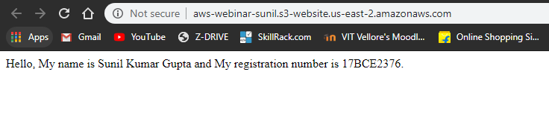

Go to Services and Click on VPC

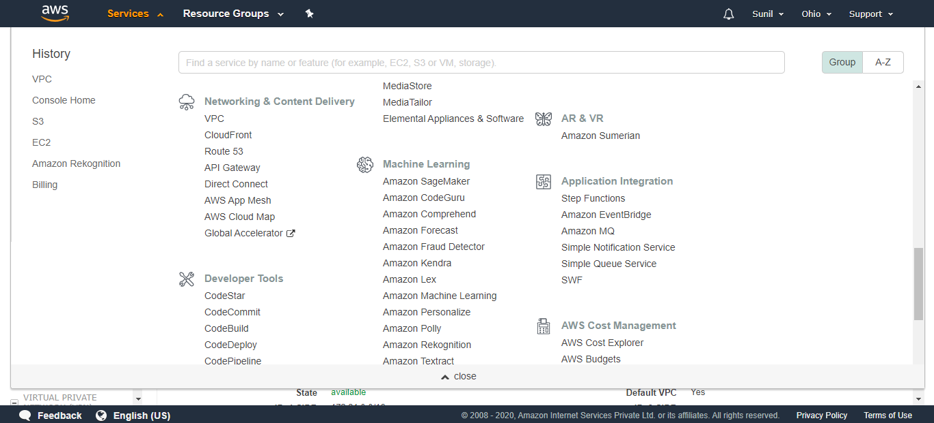

Click on VPCs

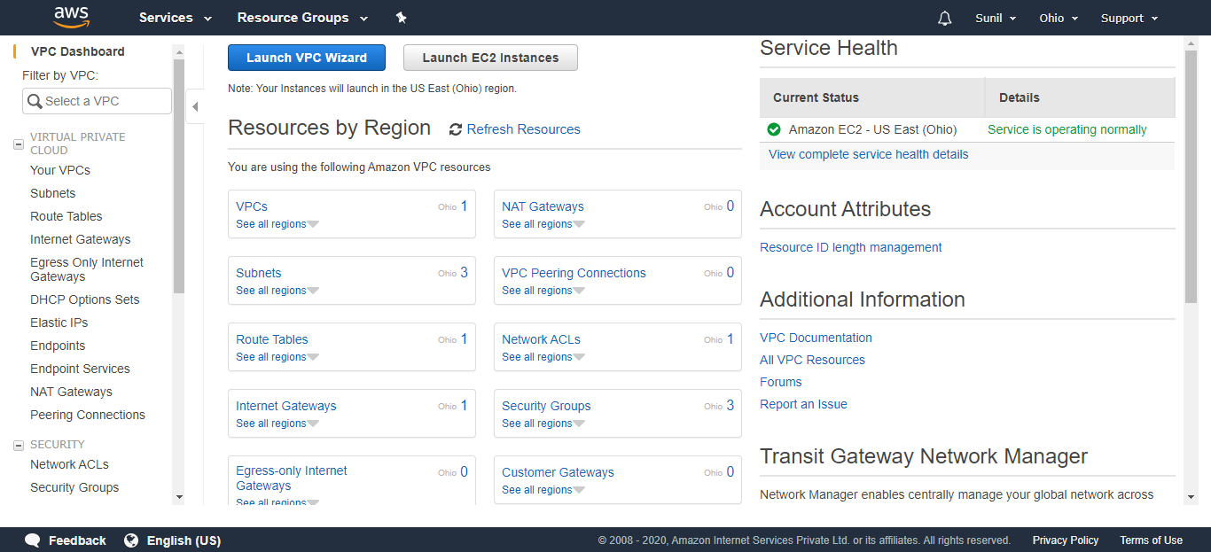

You can see your VPCs

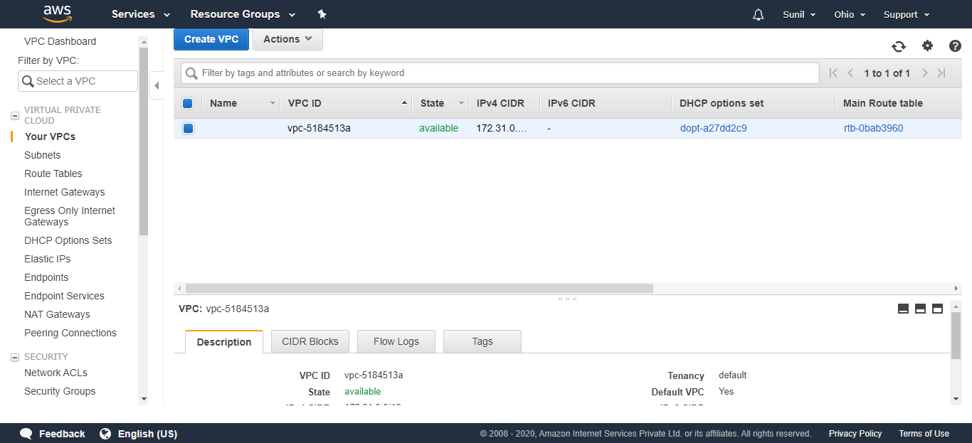

Click on subnet to see available subnets

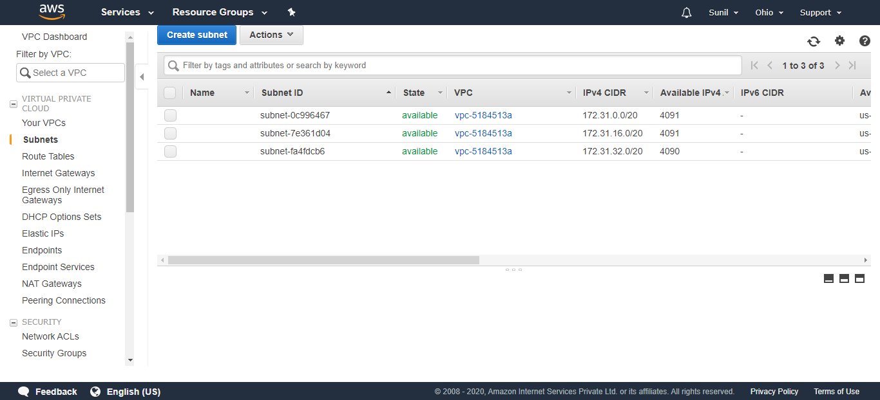

Amazon Rekognition

1. Face Detection

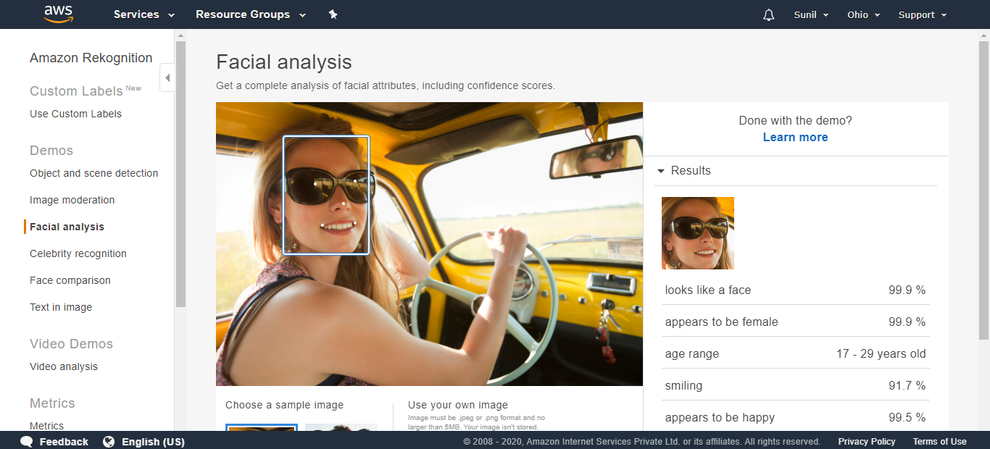

2. Celebrity recognition

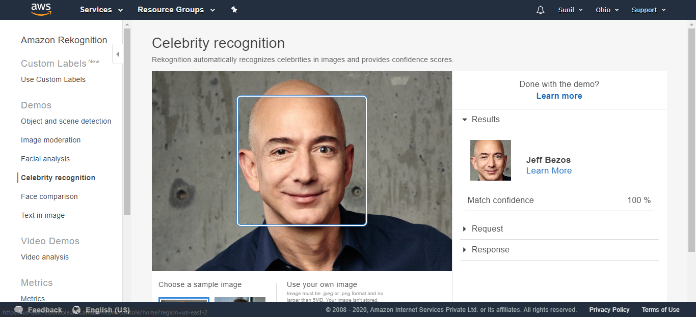

3. Face comparison

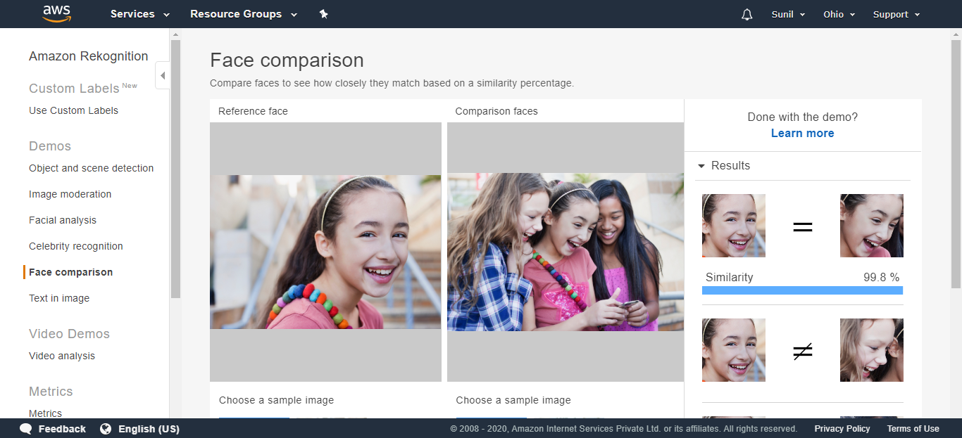

4. Text in image

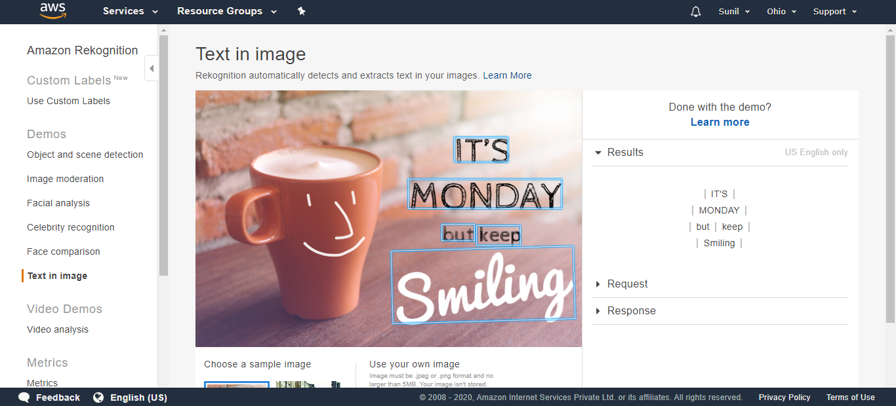

**EC2 and S3**

Go to EC2 instance and copy the IP address of running instance

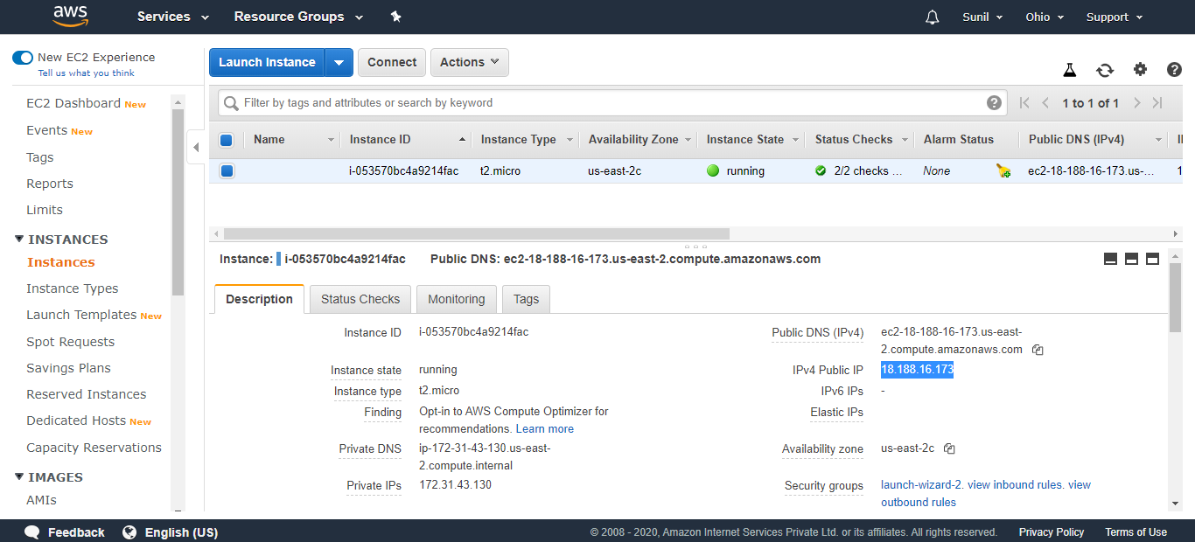

Open PuTTY and paste the IP address

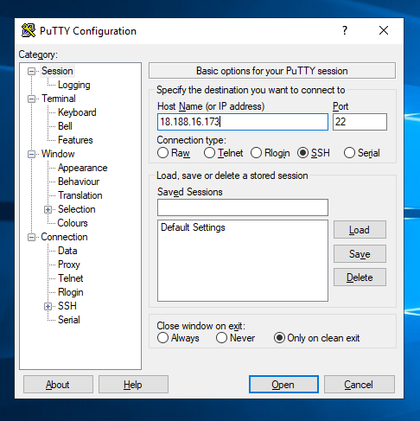

Click on SSH and Select Auth, now browse the key pair with extension .ppk

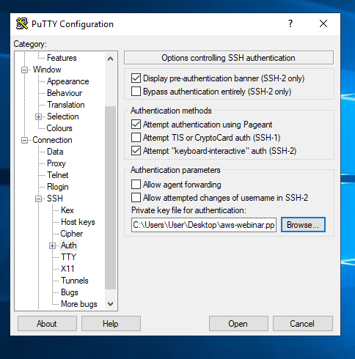

Login as ec2-user

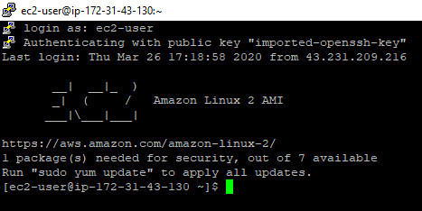

Install PHP using the following command

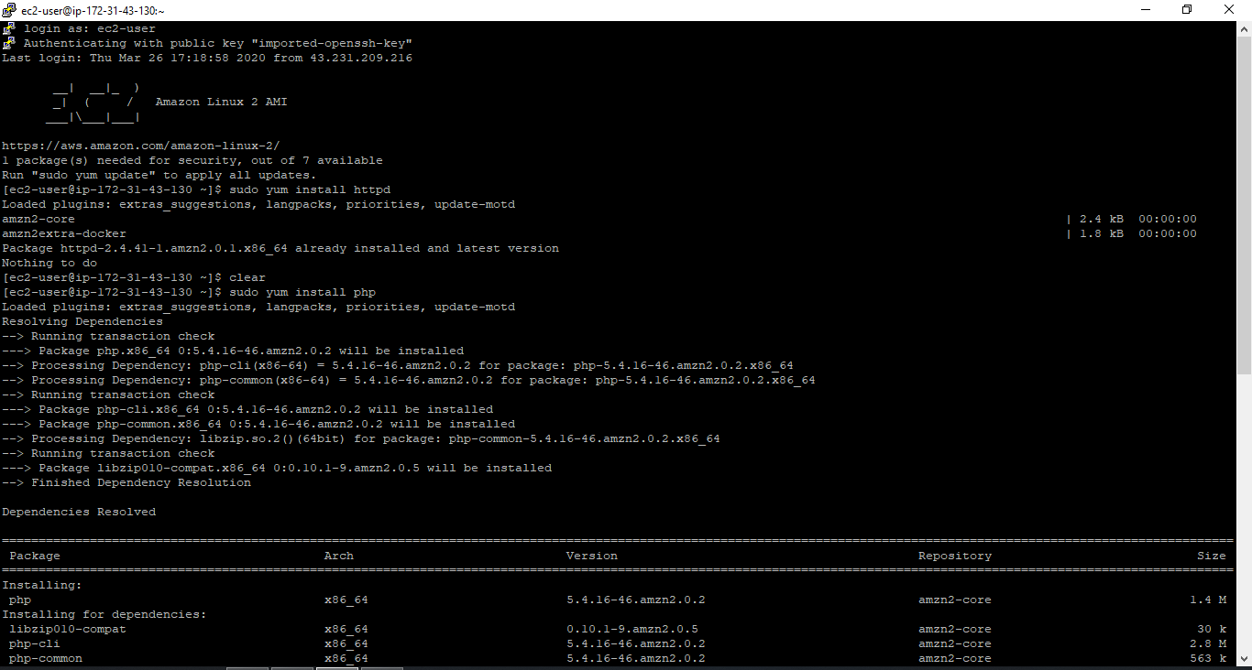

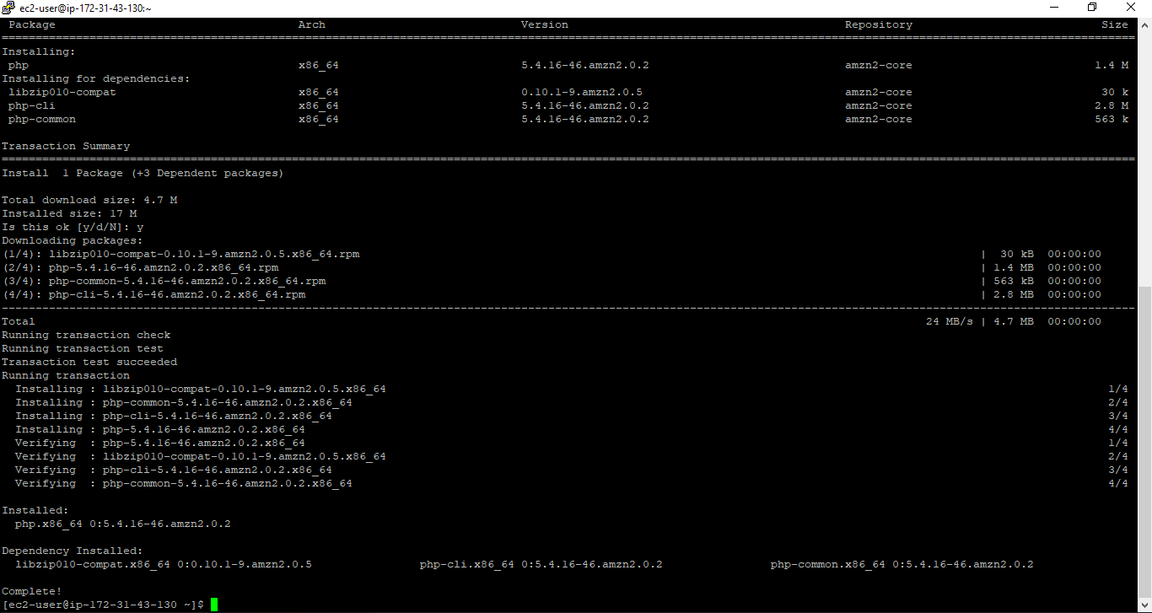

Download and install the composer using php

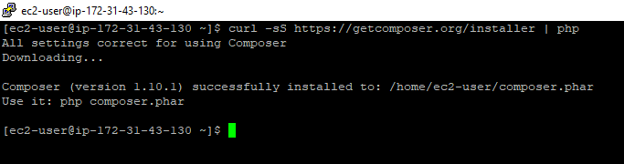

Change the directory, Create a directory called face and change the directory to face

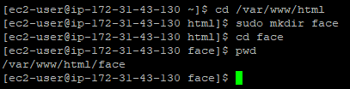

Install aws-sdk using the following command

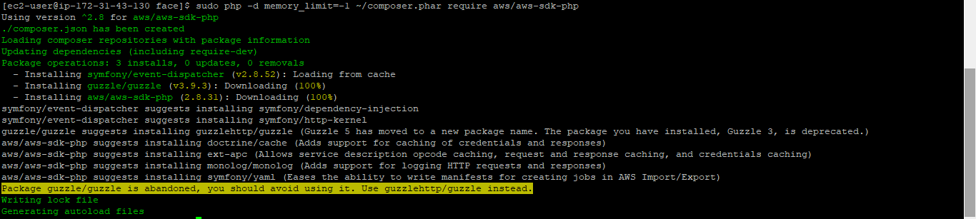

Download an image using the following command

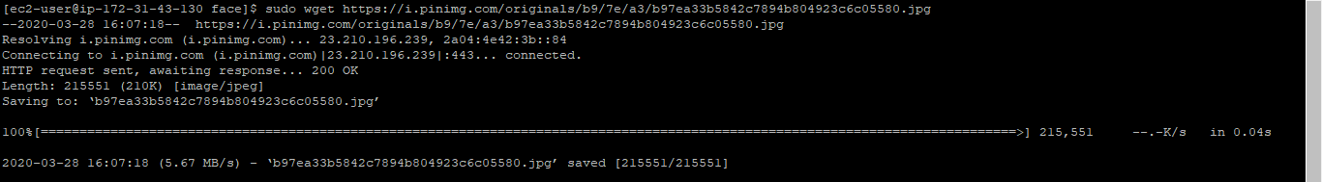

Index.php code

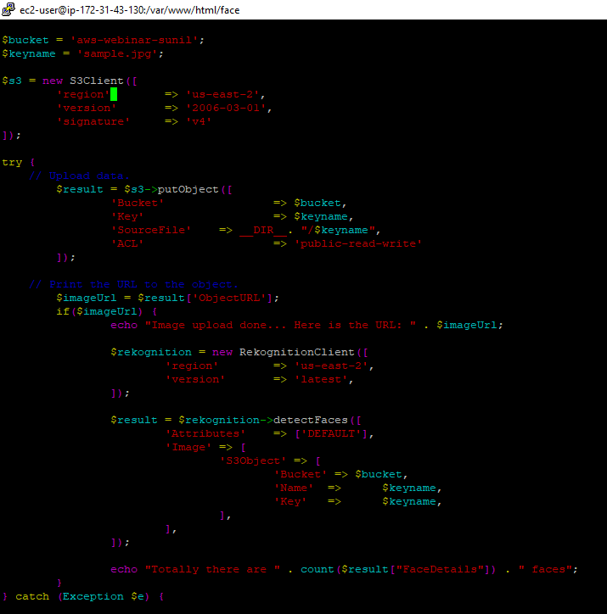

Rename the file name using following command

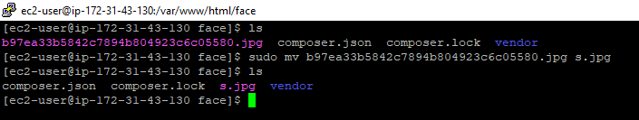

Go to Services and Search for IAM

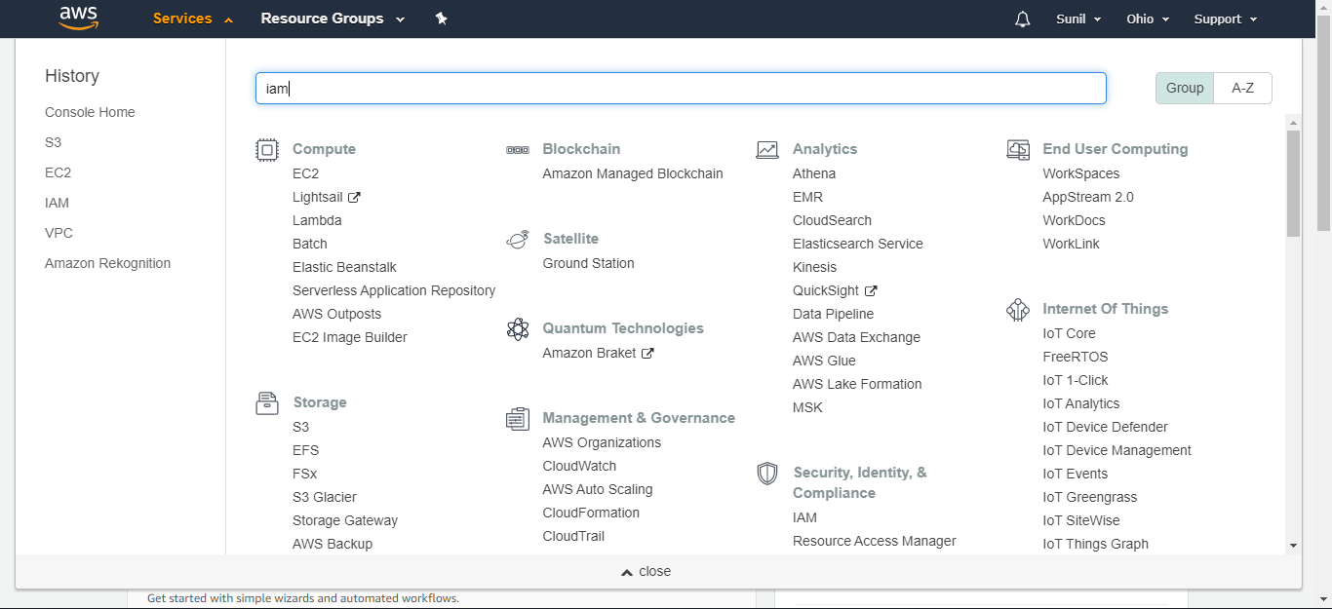

Now, Click on Roles on left hand side

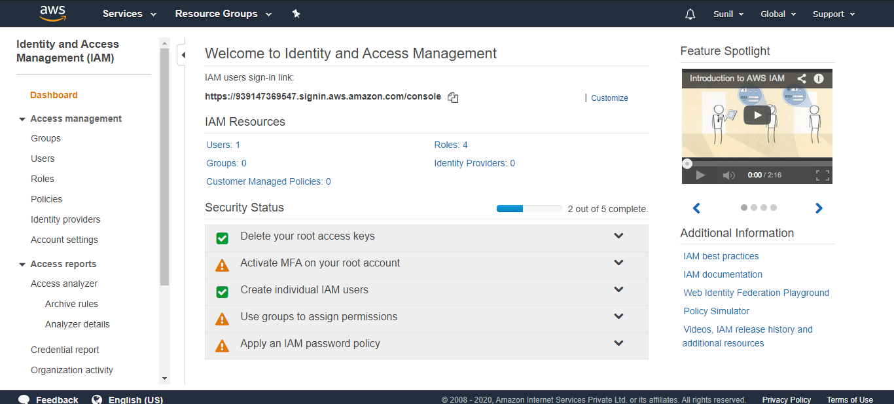

Click on Create role

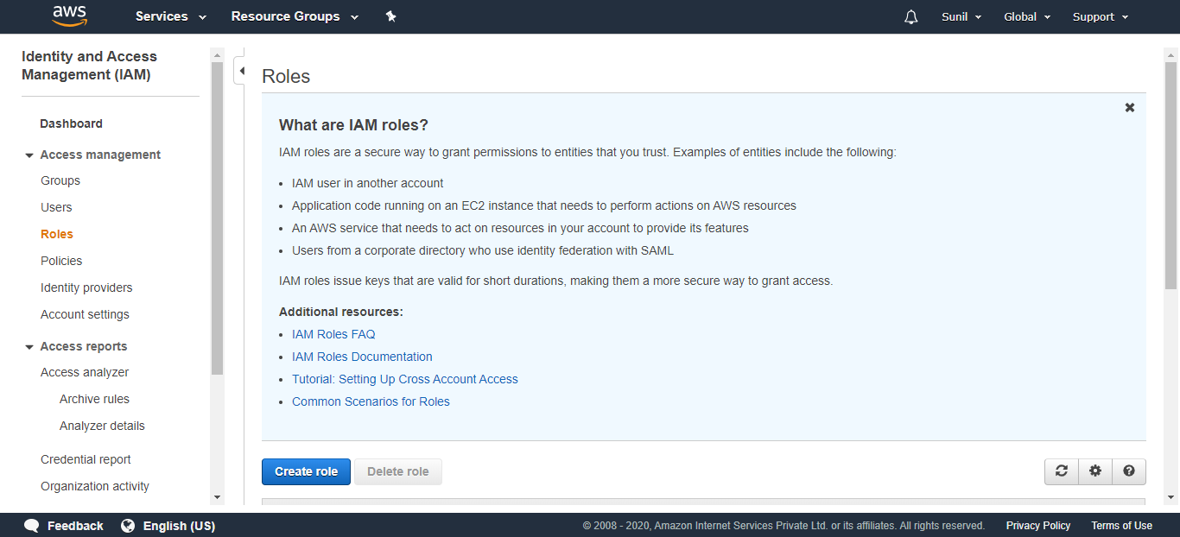

Click on AWS service and EC2

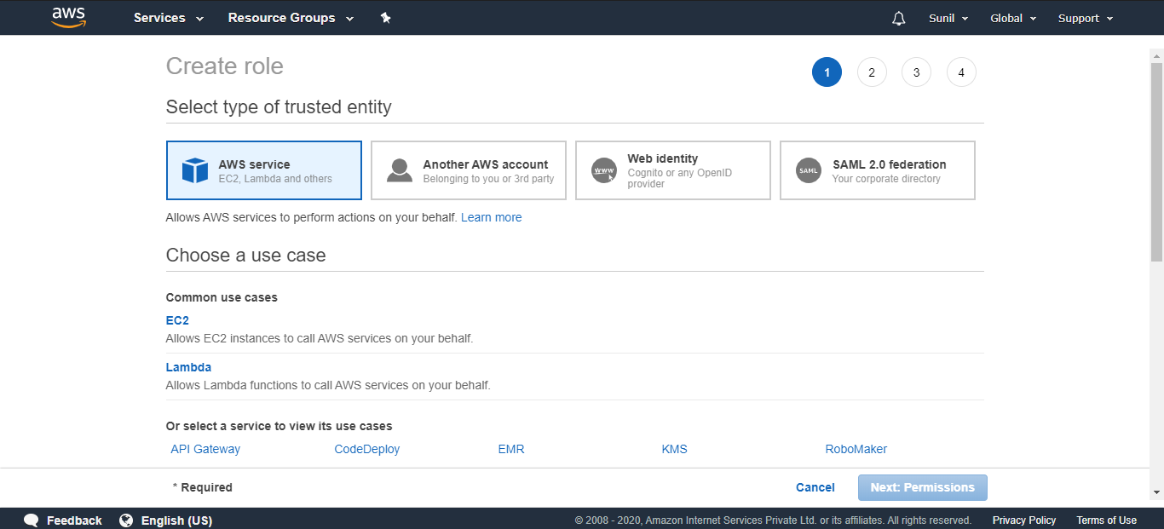

Search for AmazonS3FullAccess and Select

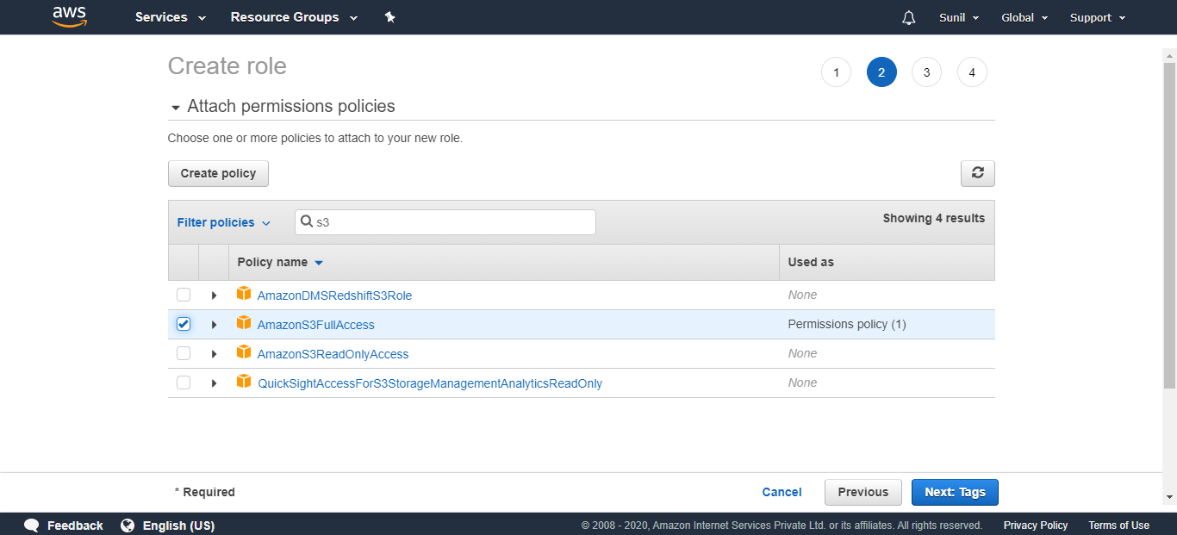

Again, Search for AmazonRekognitionFullAccess and Select

Click on Next:Tags

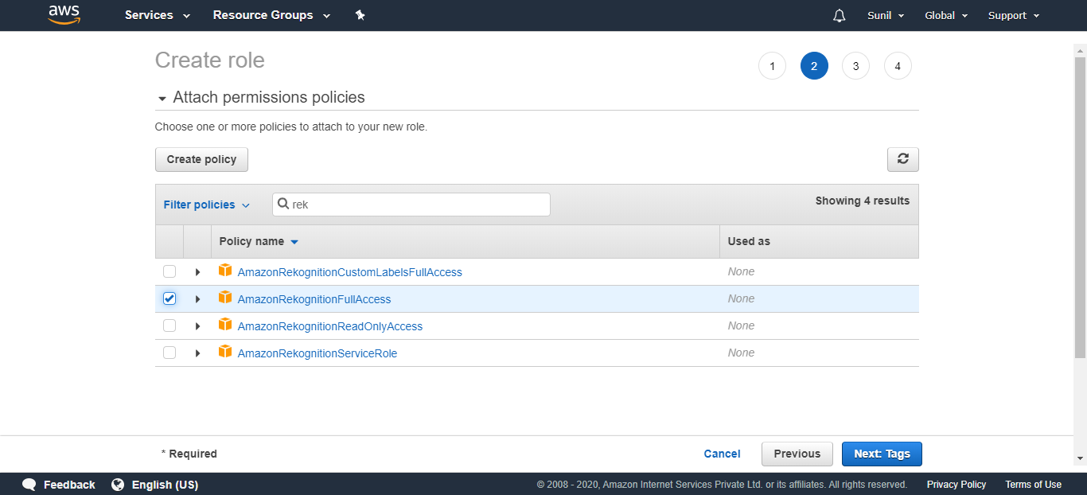

Click on Next: Review

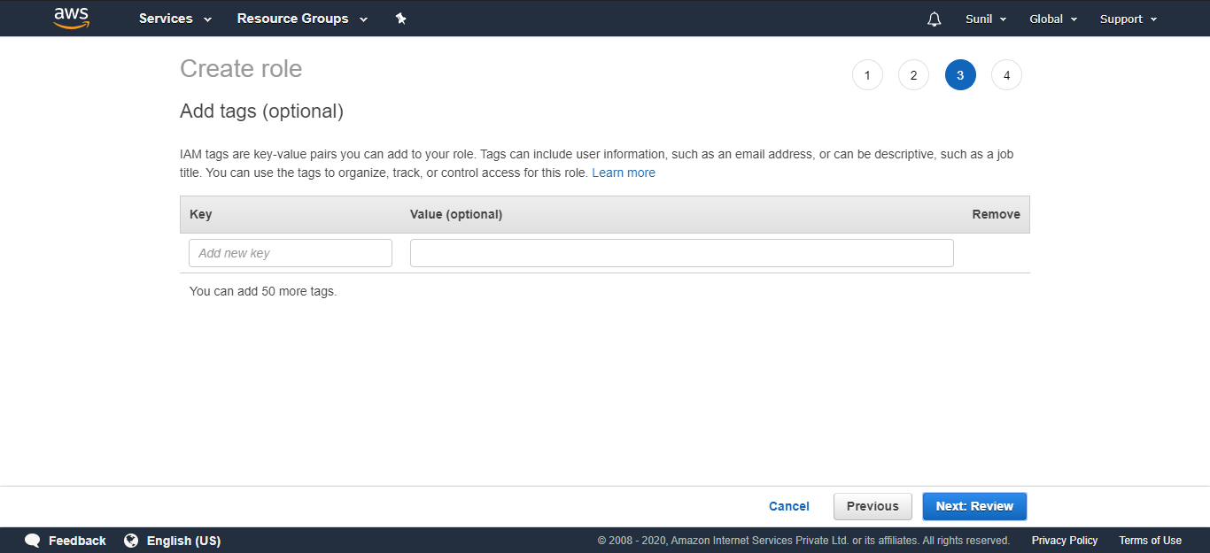

Give the Role (It can be Anything)

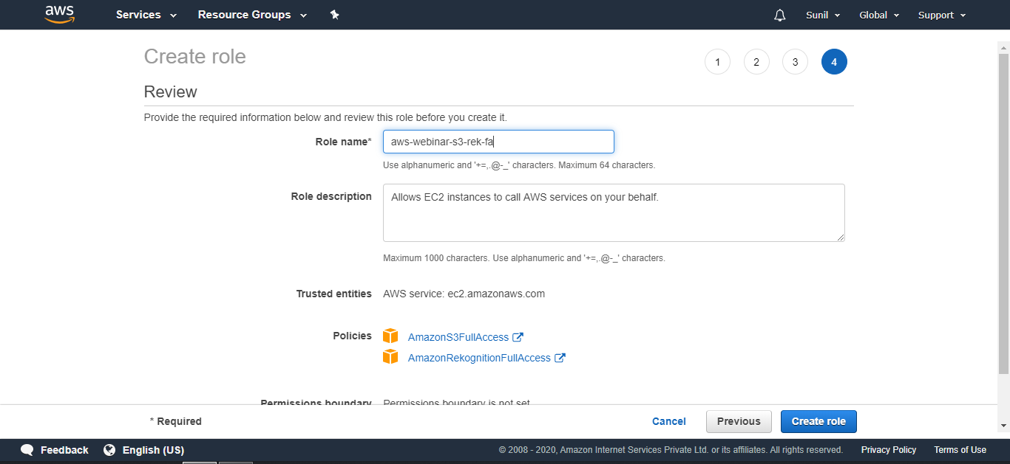

We will go to EC2 dashboard and select the instance and go to the option to Attach/Replace IAM Role

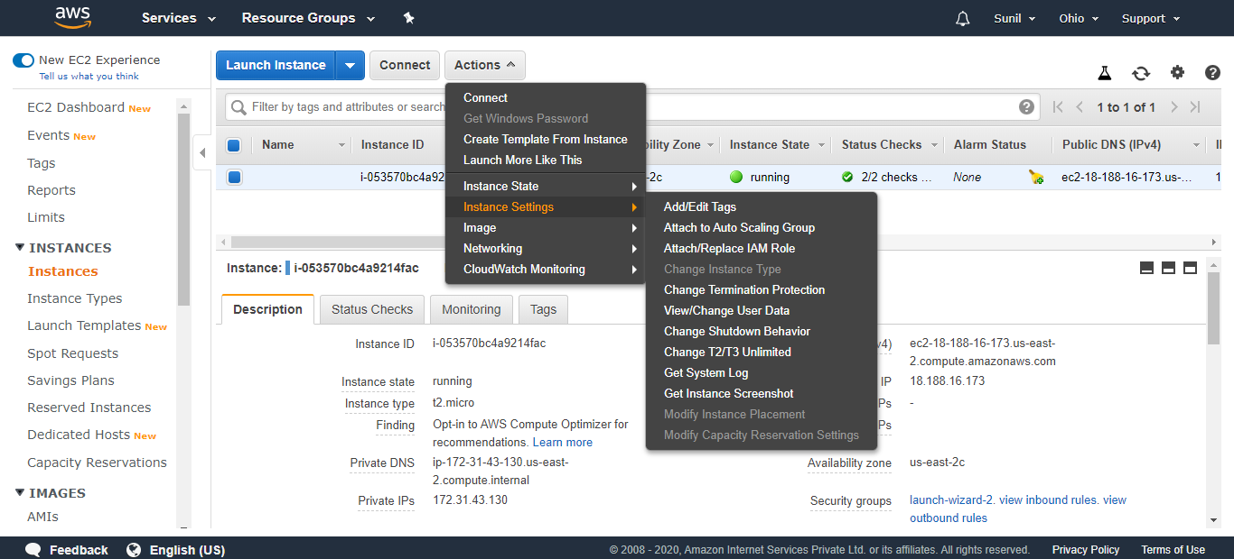

Select the role we just created

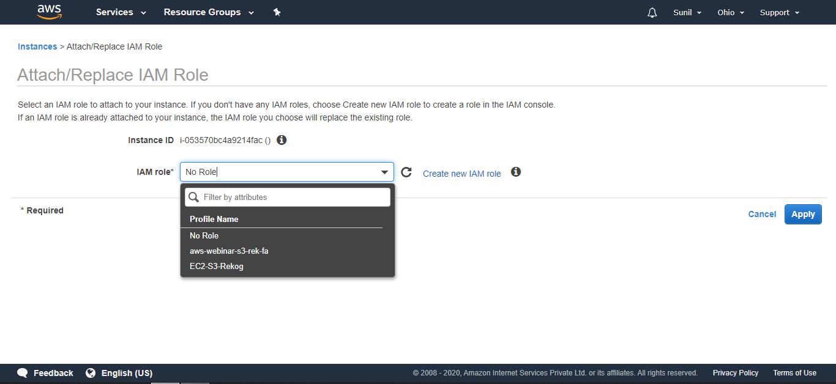

Click on Apply

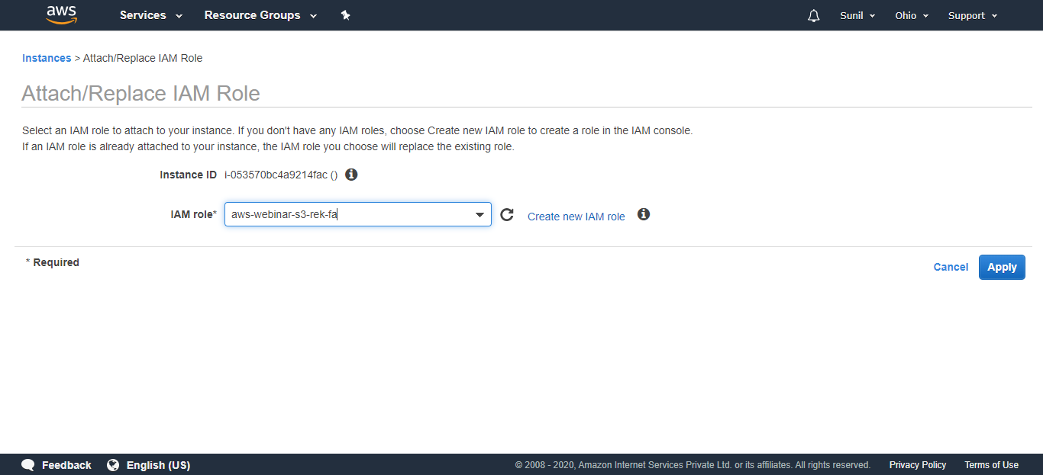

You will get this message: IAM role operation succeeded

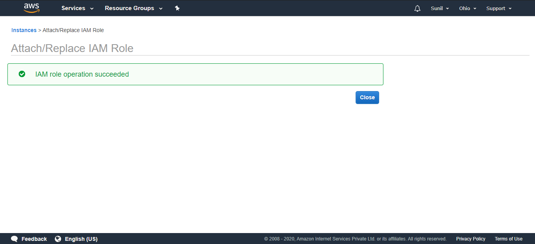

**EC2 and Rekognition**

Final Output (Upload success and Face Delected)

